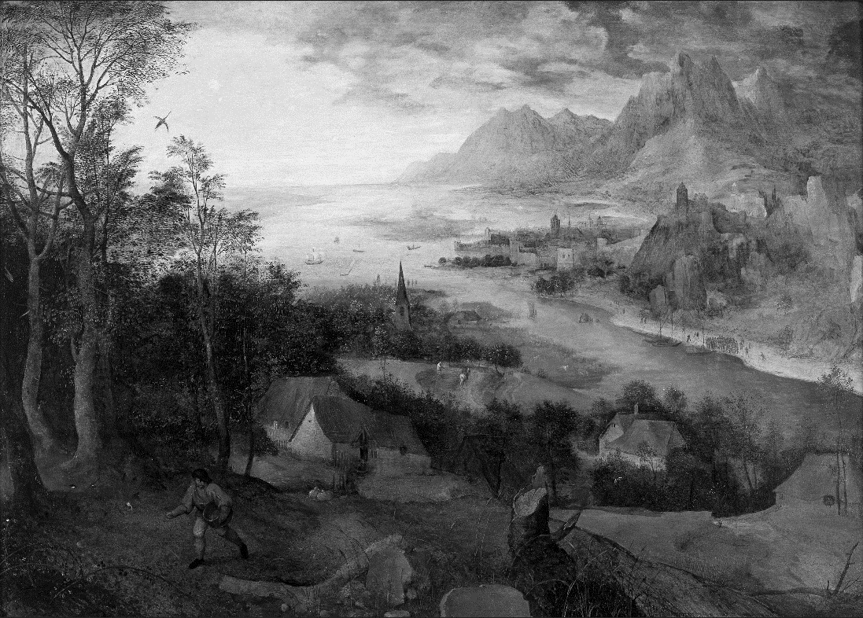

Pieter Bruegel the Elder, The Parable of the Sower, 1557.

Music of the Mass: Mass for Saint Anthony Lou Harrison (1917–2003)
Sung by the choir

All stand at the bell.

Introit Antiphon Exaudi, Domine, vocem meam (Mode IV)
Hearken, O Lord, unto my voice, wherewith I cried unto thee: be thou my succour, leave me not, neither forsake me, O God of my salvation. Psalm 27: 7, 9

Hymn 621 Light's abode, celestial Salem Rhuddlan
Opening Acclamation and Collect For Purity Mass Booklet, Page 1

Kyrie Eleison Sung by the choir Mass Booklet, Page 1

Gloria In Excelsis Deo Sung by the choir Mass Booklet, Page 2

Collect of the Day
Celebrant The Lord be with you.
People And with thy spirit.
Celebrant Let us pray.
Keep, O Lord, we beseech thee, thy household the Church in thy steadfast faith and love, that by the help of thy grace we may proclaim thy truth with boldness, and minister thy justice with compassion; for the sake of our Savior Jesus Christ, who liveth and reigneth with thee and the Holy Spirit, one God, now and for ever. Amen.

All sit.

The Liturgy of the Word

First Lesson Ezekiel 17:22–24
Thus says the Lord God: I myself will take a sprig from the lofty top of a cedar; I will set it out. I will break off a tender one from the topmost of its young twigs; I myself will plant it on a high and lofty mountain. On the mountain height of Israel
I will plant it, in order that it may produce boughs and bear fruit, and become a noble cedar. Under it every kind of bird will live; in the shade of its branches will nest winged creatures of every kind. All the trees of the field shall know that I am the Lord. I bring low the high tree, I make high the low tree; I dry up the green tree and make the dry tree flourish. I the Lord have spoken; I will accomplish it.

Reader The Word of the Lord.
People Thanks be to God.

Psalm 20 Sung by the choir Exaudiat te Dominus (Tone VII.5)
1 The Lord hear thee in the day of trouble;
the Name of the God of Jacob defend thee:
2 Send thee help from the sanctuary,
and strengthen thee out of Sion:
3 Remember all thy offerings,
and accept thy burnt-sacrifice:
4 Grant thee thy heart’s desire,
and fulfil all thy mind.
5 We will rejoice in thy salvation, and triumph in the Name of the Lord our God:
the Lord perform all thy petitions.
6 Now know I that the Lord helpeth his anointed, and will hear him from his holy heaven,
even with the wholesome strength of his right hand.
7 Some put their trust in chariots, and some in horses;
but we will remember the Name of the Lord our God.
8 They are brought down and fallen;
but we are risen and stand upright
9 Save, Lord; and hear us, O King of heaven,
when we call upon thee.

Epistle 2 Corinthians 5:6–17
We are always confident; even though we know that while we are at home in the body we are away from the Lord– for we walk by faith, not by sight. Yes, we do have confidence, and we would rather be away from the body and at home with the Lord. So whether we are at home or away, we make it our aim to please him. For all of us must appear before the judgment seat of Christ, so that each may receive recompense for what has been done in the body, whether good or evil.

Therefore, knowing the fear of the Lord, we try to persuade others; but we ourselves are well known to God, and I hope that we are also well known to your consciences. We are not commending ourselves to you again, but giving you an opportunity to boast about us, so that you may be able to answer those who boast in outward appearance and not in the heart. For if we are beside ourselves, it is for God; if we are in our right mind, it is for you. For the love of Christ urges us on, because we are convinced that one has died for all; therefore all have died. And he died for all, so that those who live might live no longer for themselves, but for him who died and was raised for them. From now on, therefore, we regard no one from a human point of view; even though we once knew Christ from a human point of view, we know him no longer in that way. So if anyone is in Christ, there is a new creation: everything old has passed away; see, everything has become new!

Subdeacon The Word of the Lord.
People Thanks be to God.

All stand.

Alleluia Verse Domine, in virtute tua laetabitur Rex
Sung by the cantors, then repeated by all. After the cantors sing the verse, all repeat the Alleluia.
V. O Lord, the King shall rejoice in thy strength: and exceeding glad shall he be of thy salvation. Psalm 21:1.

Hymn 209 We walk by faith St. Botolph

The Holy Gospel Mark 4:26–34
Deacon The Lord be with you.
People And with thy spirit.
Deacon The  Holy Gospel of our Lord Jesus Christ according to Mark.
People Glory be to thee, O Lord.
Jesus said, “The kingdom of God is as if someone would scatter seed on the ground, and would sleep and rise night and day, and the seed would sprout and grow, he does not know how. The earth produces of itself, first the stalk, then the head, then the full grain in the head. But when the grain is ripe, at once he goes in with his sickle, because the harvest has come.”

He also said, “With what can we compare the kingdom of God, or what parable will we use for it? It is like a mustard seed, which, when sown upon the ground, is the smallest of all the seeds on earth; yet when it is sown it grows up and becomes the greatest of all shrubs, and puts forth large branches, so that the birds of the air can make nests in its shade.”

With many such parables he spoke the word to them, as they were able to hear it; he did not speak to them except in parables, but he explained everything in private to his disciples.

Deacon The Gospel of the Lord.
People Praise be to thee, O Christ.

All sit.

Sermon The Rev'd Richard Wall

All stand.

The Nicene Creed Mass Booklet, Page 4

Prayers of the People, Form I Mass Booklet, Page 6

The Confession of Sin Mass Booklet, Page 8

The Peace Mass Booklet, Page 9

The Holy Communion

Offertory Antiphon Benedicam Dominum, qui tribuit mihi intellectum (Tone I)
I will bless the Lord, who hath given me understanding: I have set God always before me; for he is on my right hand: therefore I shall not fall. Psalm 16: 7–8

Offertory Anthem A Sermon on Miracles Ned Rorem (b. 1923)

I asked, "What is a miracle? And what would be a miracle today?"
Some said, "There cannot be a miracle today because we know too much."
One more wisely said, "Music that freely moves me to joy and sadness is a miracle."
No, no. A miracle works more than the spell of spellbound music.

It works life; it awakens a dead body to behavior,
and my cold heart to love such as I did not know I knew.

Brothers are at war,
There is coldness between man and wife, and the children hate the elders.

But this miraculous child, this ancient, enters the house,
with a quick gesture, a still word,
and there is peace and affection in the family
and new inventions for happiness.

Creator Spirit, come!
For our bodies are dead and our souls are in bondage.
Creator Spirit, come!

Text: Paul Goodman (1911-1972)
Music: Ned Rorem (b. 1923)

All stand to be censed, and remain standing.

Orate Fratres Ac Sorores Mass Booklet, Page 10

Eucharistic Prayer I Mass Booklet, Page 11

Sanctus Et Benedictus Sung by the choir Mass Booklet, Page 11

The Lord’s Prayer Mass Booklet, Page 13

The Breaking of the Bread Mass Booklet, Page 17

Ecce Agnus Dei Mass Booklet, Page 17

Agnus Dei Sung by the choir
Agnus Dei, qui tollis peccata mundi, miserere nobis.
Agnus Dei, qui tollis peccata mundi, miserere nobis.
Agnus Dei, qui tollis peccata mundi, dona nobis pacem.

O Lamb of God, that takest away the sins of the world, have mercy upon us.
O Lamb of God, that takest away the sins of the world, have mercy upon us.
O Lamb of God, that takest away the sins of the world, grant us thy peace.

All baptized Christians are welcome to receive the Eucharist at the Lord’s Table. If you are not receiving, you are invited to come forward for a blessing (indicated by crossing your arms over your chest). If you have not been baptized, and find yourself drawn to Jesus Christ and life in him, please let one of our clergy know. We would be honored to have a conversation with you about the possibility of baptism, or any other questions. Baptism and life in the Body of Christ is open to all.

Communion Antiphon Unam petii a Domino, hanc requiram (Mode VI)
One thing have I desired from the Lord, which I will require: even that I may dwell in the house of the Lord all the days of my life. Psalm 27:4

Hymn 601 O day of God, draw nigh St. Michael
Post Communion Prayer Mass Booklet, Page 17

The Blessing Mass Booklet, Page 18

Dismissal Mass Booklet, Page 18

Hymn 538 God of mercy, God of grace Lucerna Laudioniae

  

Thank you for joining us this Sunday at St. Paul’s. We were privileged to have you with us, and invite you to return and to worship with us again. All are welcome to partake of refreshments on the Parish Lawn at the conclusion of the service.

We are back to gathering in-person as our health allows, and virtually on selected occasions. Please join us:

Weekday Low Mass at 10 a.m. Tuesday and Thursday

Evening Prayer at 6 p.m. Monday, Tuesday, Wednesday (via Zoom)

Faith Formation at 6:30 p.m. Wednesday (via Zoom)

Weekend Low Mass at 11:30 a.m. Saturday

Mass on the Grass at 9:00 a.m. Sunday (weather permitting, please see the weekly e-blast for details) on the West Lawn near the Columbarium

Solemn Mass at 10:30 a.m. Sunday

Zoom https://zoom.us/j/7183945686
Dial-in: +1 929 205 6099, 7183945686#
Password: 156028

You can learn more about St. Paul’s on:

Facebook https://www.facebook.com/stpaulskst/

YouTube https://www.youtube.com/user/StPaulsKStreet

Instagram @stpauls.kst

Website http://www.saintpaulskstreet.org/

Thank you to all our parishioners who are making their pledge donations online or who are mailing in their checks to St. Paul’s. Please consider supporting the work of St. Paul’s by making a pledge for 2021: http://www.saintpaulskstreet.org/stewardship/pledge/. If you have previously put your pledge in the plate, it would be of great value to the parish if you would consider using the website to make your pledge gift. You can contribute easily from our website by following this link: http://www.saintpaulskstreet.org/stewardship/make-a-general-contribution/ or text STPKST to 73256. Checks may also be mailed directly to St. Paul’s.

A Note on Today’s Music

Were we in Padua today, it would be hard to ignore the annual celebration of Saint Anthony (b. 1195). His feast day, June 13, is marked by processions, street fairs, fireworks, and the unbuttoned revelry to which Italians often aspire. The Mass for Saint Anthony was written over a decade beginning in 1939. Throughout his long career, Lou Harrison (1917–2003) rebelled against the academic/concert establishment by writing tonal music, albeit music inflected with non-Western modalities. As far as I know, today marks the first liturgical performance of the piece in the Mid-Atlantic region.

Of 20th century song composers, Ned Rorem (b. 1923) stands out among Americans. He remained active in concerts and composition well into his eighties. With a specially written text by Paul Goodman, A Sermon on Miracles premiered in Boston in 1947. Rorem contributed the Harrison entry in the New Grove Dictionary of Music, remarking that during the war years Harrison "joined Cage in organizing recitals of percussion music, while working as a florist, record clerk, poet, dancer and dance critic, music copyist (his handwriting is known for its beauty), playwright and builder of instruments from found objects." Then as now, composers are often the most flexible in the trade.

-Jeffrey Smith

