The Conversion of Saint Paul, Benvenuto Tisi, c. 1525.

The District of Columbia has reinstated indoor mask mandates, which includes churches. While the mandate is in place, and at the direction of the Bishop, we will not be offering hospitality events, and masks must be worn during Mass and at all other St. Paul’s events. Masks are available at the back of the church upon request.

Solemn Mass 10:30 a.m.

The Music of the Mass Communion Service in F Harold Darke (1888–1976)

All stand at the bell.

Introit Antiphon Laetemur omnes in Domino (Mode VII)
Let us all be glad in the Lord, devoutly keeping this festival with due solemnity:
wherein holy Paul, by his wonderful conversion, did greatly illumine this present
world.

The Solemn Procession

Procedamus in pace
Deacon Let us go forth in peace:
People In the Name of Christ. Amen.

Hymn We sing the glorious conquest Munich

Station at the Icon of Saint Paul

Celebrant O holy Apostle Paul, thou Preacher of truth and Doctor of the Gentiles:
People Intercede for us unto God who hath chosen thee.
Celebrant Let us pray.
O God, who hast hallowed this day by the remembrance of the glorious conversion of thy blessed Apostle Saint Paul: Grant that as by him thy Church was taught the first principles of faith and worship; so also thy people may in all things fulfil his precepts and show forth in their lives the grace of the Gospel which he preached; through thy Son Jesus Christ our Lord, who with thee, in the unity of the Holy Spirit, liveth and reigneth, one God, now and forever. Amen.

Hymn 520 Blessed city, heavenly Salem Oriel

Station at the Chancel Steps

Celebrant The righteous live for evermore:
People Their reward also is with the Lord.
Celebrant Let us pray.
O Almighty God, who hast knit together thine elect in one communion and fellowship in the mystical body of thy Son Christ our Lord: Grant us grace so to follow thy blessed saints in all virtuous and godly living, that we may come to those ineffable joys which thou has prepared for those who unfeignedly love thee; through the same Jesus Christ our Lord, who with thee and the Holy Spirit liveth and reigneth, one God, in glory everlasting. Amen.

Kyrie Eleison & Gloria in Excelsis Deo Mass Booklet, Pages 1 & 2
from the Cantus Missæ in E-flat, sung by the choir

Collect of the Day
Celebrant The Lord be with you.
People And with thy spirit.
Celebrant Let us pray.
O God, who, by the preaching of thine apostle Paul, hast caused the light of the Gospel to shine throughout the world: Grant, we beseech thee, that we, having his wonderful conversion in remembrance, may show forth our thankfulness unto thee for the same by following the holy doctrine which he taught; through Jesus Christ our Lord, who liveth and reigneth with thee, in the unity of the Holy Spirit, one God, now and for ever. Amen.

First Lesson Acts 26:9–21
After he was in prison for some time, Paul was permitted to state his case before King Agrippa. Paul said to the King, “Indeed, I myself was convinced that I ought to do many things against the name of Jesus of Nazareth. And that is what I did in Jerusalem; with authority received from the chief priests, I not only locked up many of the saints in prison, but I also cast my vote against them when they were being condemned to death. By punishing them often in all the synagogues I tried to force them to blaspheme; and since I was so furiously enraged at them, I pursued them even to foreign cities. With this in mind, I was traveling to Damascus with the authority and commission of the chief priests, when at midday along the road, your Excellency, I saw a light from heaven, brighter than the sun, shining around me and my companions. When we had all fallen to the ground, I heard a voice saying to me in the Hebrew language, ‘Saul, Saul, why are you persecuting me? It hurts you to kick against the goads.’ I asked, ‘Who are you, Lord?’ The Lord answered, ‘I am Jesus whom you are persecuting. But get up and stand on your feet; for I have appeared to you for this purpose, to appoint you to serve and testify to the things in which you have seen me and to those in which I will appear to you. I will rescue you from your people and from the Gentiles—to whom I am sending you to open their eyes so that they may turn from darkness to light and from the power of Satan to God, so that they may receive forgiveness of sins and a place among those who are sanctified by faith in me.’ After that, King Agrippa, I was not disobedient to the heavenly vision, but declared first to those in Damascus, then in Jerusalem and throughout the countryside of Judea, and also to the Gentiles, that they should repent and turn to God and do deeds consistent
with repentance. For this reason the Jews seized me in the temple and tried to kill me.”

Reader The Word of the Lord.
People Thanks be to God.

Psalm 84 Quam dilecta! Chant: C. Hubert H Parry (1848–1918)

1 O how amiable are thy dwellings:
thou Lord of hosts!
2 My soul hath a desire and longing to enter into the courts of the Lord:
my heart and my flesh rejoice in the living God.
3 Yea the sparrow hath found her an house,
and the swallow a nest where she may lay her young:
even thy altars O Lord of hosts, my King and my God.
4 Blessed are they that dwell in thy house:
they will be alway praising thee.
5 Blessed is the man whose strength is in thee:
in whose heart are thy ways.
6 Who going through the vale of misery use it for a well:
and the pools are filled with water.
7 They will go from strength to strength:
and unto the God of gods appeareth every one of them in Sion.

Second Epistle Galatians 1:11–24
I want you to know, brothers and sisters, that the gospel that was proclaimed by me is not of human origin; for I did not receive it from a human source, nor was I taught it, but I received it through a revelation of Jesus Christ. You have heard, no doubt, of my earlier life in Judaism. I was violently persecuting the church of God and was trying to destroy it. I advanced in Judaism beyond many among my people of the same age, for I was far more zealous for the traditions of my ancestors. But when God, who had set me apart before I was born and called me through his grace, was pleased to reveal his Son to me, so that I might proclaim him among the Gentiles, I did not confer with any human being, nor did I go up to Jerusalem to those who were already apostles before me, but I went away at once into Arabia, and afterwards I returned to Damascus. Then after three years I did go up to Jerusalem to visit Cephas and stayed with him fifteen days; but I did not see any other apostle except James the Lord’s brother. In what I am writing to you, before God, I do not lie! Then I went into the regions of Syria and Cilicia, and I was still unknown by sight to the churches of Judea that are in Christ; they only heard it said, “The one who formerly was persecuting us is now proclaiming the faith he once tried to destroy.” And they glorified God because of me.

Reader The Word of the Lord.
People Thanks be to God.

Hymn 232 By all your saints still striving Nyland
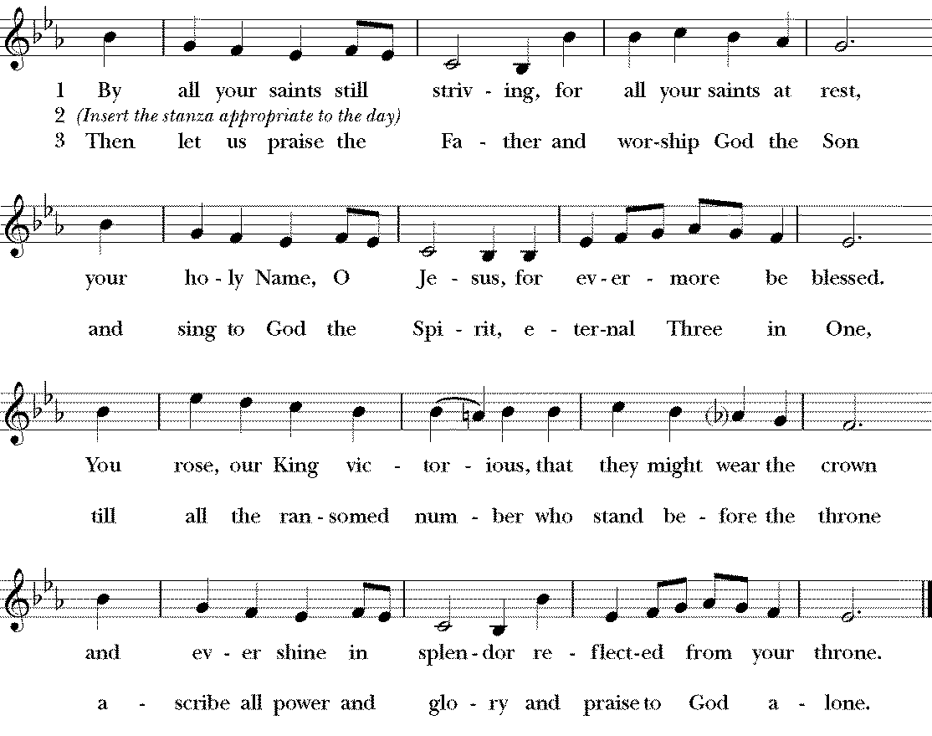
- Praise for the light from heaven and for the voice of awe,
Praise for the glorious vision the persecutor saw.
O Lord, for Paul’s conversion, we bless your name today.
Come shine within our darkness and guide us in the Way.

Alleluia Verse Magnus Sanctus Paulus (Mode II)
Sung by the cantors, then repeated by all. After the cantors sing the verse, all repeat the Alleluia.
V. Great Saint Paul, the chosen vessel, is meet indeed to be glorified; who also was worthy to possess the twelfth throne.

The Holy Gospel Matthew 10:16–22
Deacon The Lord be with you.
People And with thy spirit.
Deacon The Holy Gospel of our Lord Jesus Christ according to Matthew.
People Glory be to thee, O Lord.
Jesus said, “See, I am sending you out like sheep into the midst of wolves; so be wise as serpents and innocent as doves. Beware of them, for they will hand you over to councils and flog you in their synagogues; and you will be dragged before governors and kings because of me, as a testimony to them and the Gentiles. When they hand you over, do not worry about how you are to speak or what you are to say; for what you are to say will be given to you at that time; for it is not you who speak, but the Spirit of your Father speaking through you. Brother will betray brother to death, and a father his child, and children will rise against parents and have them put to death; and you will be hated by all because of my name. But the one who endures to the end will be saved.”

Deacon The Gospel of the Lord.
People Praise be to thee, O Christ.

Sermon The Rev’d Richard Wall

The Nicene Creed Mass Booklet, Page 4

The Prayers of the People, Form I Mass Booklet, Page 6

The Confession of Sin Mass Booklet, Page 8

The Peace Mass Booklet, Page 9

The Holy Communion

Offertory Antiphon Mihi autem nimis (Tone III)
But unto me are thy friends held in highest honor: O how great is the preeminence
of them. cf. Psalm 139:16

Offertory Anthem
Felix Mendelssohn-Bartholdy (1809–1847) (from the oratorio Saint Paul, Op. 36)

How lovely are the messengers that preach us the gospel of peace,
to all the nations is gone forth the sounds of their words,
throughout all the lands their glad tidings.

[cf. Isaiah 52.7; Nahum 1.15; Psalm 19.4]

All stand to be censed, and remain standing.

Orate Mass Booklet, Page 10

Eucharistic Prayer I Mass Booklet, Page 13

Sanctus Et Benedictus Mass Booklet, Page 13
from the Cantus Missæ in E-flat, sung by the choir

The Lord’s Prayer Mass Booklet, Page 16

The Breaking of the Bread Mass Booklet, Page 17

Agnus Dei

Agnus Dei, qui tollis peccata mundi, miserere nobis.
Agnus Dei, qui tollis peccata mundi, miserere nobis.
Agnus Dei, qui tollis peccata mundi, dona nobis pacem.

O Lamb of God, that takest away the sins of the world, have mercy upon us.
O Lamb of God, that takest away the sins of the world, have mercy upon us.
O Lamb of God, that takest away the sins of the world, grant us thy peace.

Ecce Agnus Dei Mass Booklet, Page 17

All baptized Christians are welcome to receive the Eucharist at the Lord’s Table. If you are not receiving, you are invited to come forward for a blessing (indicated by crossing your arms over your chest). If you have not been baptized, and find yourself drawn to Jesus Christ and life in him, please let one of our clergy know. We would be honored to have a conversation with you about the possibility of baptism, or any other questions. Baptism and life in the Body of Christ are open to all.

Communion Antiphon Signa eos qui in me credunt (Mode VII)
These signs shall follow them that believe in me: they shall cast out devils; they
shall lay hands on the sick, and they shall recover. Mark 16:17–18

Hymn 289 Our Father by whose servants Wolvercote

Post Communion Prayer Mass Booklet, Page 18

The Blessing Mass Booklet, Page 18

Dismissal Mass Booklet, Page 19

The Angelus Mass Booklet, Page 20

Hymn Christ is made the sure foundation Westminster Abbey
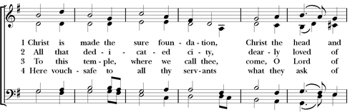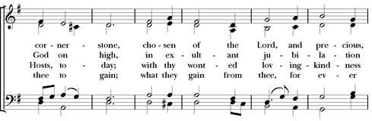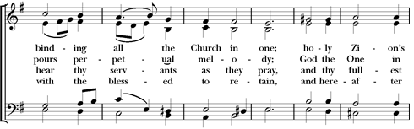
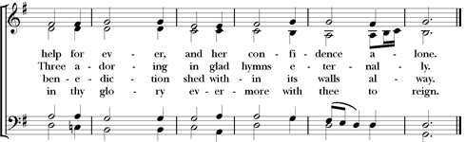

- Laud and honor to the Father, laud and honor to the Son,
Laud and honor to the Spirit, ever Three, and ever One,
Consubstantial, co-eternal, while unending ages run. Amen.

Organ Voluntary Hymne d'action de grâce: Te Deum Jean Langlais (1907–1991)

  

Thank you for joining us this Sunday at St. Paul’s. We are privileged to have you with us and invite you to return and worship with us again.

Parish Schedule: Monday, January 24th – Sunday, January 30th, 2022

Monday, January 24th
Francis De Sales, Bishop, Confessor, Doctor
5:30 p.m. Shrine Prayers
5:45 p.m. Evening Prayer
6:00 p.m. Low Mass,
Angel Chapel

Tuesday, January 25th
THE CONVERSION OF SAINT PAUL THE APOSTLE
9:45 a.m. Morning Prayer
10:00 a.m. Low Mass,
Angel Chapel
6:00 p.m. Zoom Evening Prayer
6:30 p.m. Vestry Meeting, Atrium

Wednesday, January 26th
Timothy and Titus, Companions of Saint Paul
4:40 p.m. Chorister Rehearsal,
Choir Room & Nave
6:00 p.m. Zoom Evening Prayer

Thursday, January 27th
John Chrysostom, Bishop of Constantinople
9:45 a.m. Morning Prayer
10:00 a.m. Low Mass & Unction,
Angel Chapel
4:40 p.m. Chorister Rehearsal,
Choir Room & Nave
7:00 p.m. Parish Choir,
Choir Room & Nave
7:00 p.m. AA Meeting,
Dining Hall

Friday, January 28th
Thomas Aquinas, Priest and Friar
11:30 a.m. Grate Patrol Food Prep,
Dining Hall
4:40 p.m. Chorister Rehearsal,
Choir Room & Nave

Saturday, January 29th
Epiphany Feria
5:30 a.m. Grate Patrol Delivery
No Mass – Diocesan Convention

Sunday, January 30th
The Fourth Sunday after the Epiphany
5:30 a.m. Grate Patrol Delivery
9:00 a.m. Mass on the Grass, Parish Lawn
10:30 a.m. Solemn Mass,
Nave

Parish Prayer List

In the Diocesan Cycle of Prayer, pray for: St. Paul’s Church, Baden and St. Mary’s Chapel, Aquasco; St. Paul’s Church, Rock Creek; St. Paul’s Church, K Street; St. Paul’s Church, Piney. As we prepare for Diocesan Convention (January 29), we pray for the Bishop, all Diocesan Convention Officers, and all Clerical and Lay Delegates. We pray for each person in our Diocese to deepen their relationship with Jesus.

﻿In the wider Anglican Communion, pray for: Hong Kong Sheng Kung Hui; for Justin, Archbishop of Canterbury; Michael, the Presiding Bishop; and Mariann, our own bishop; for our sister parish St. Paul’s Knightsbridge, London; for the Episcopal Diocese of Jerusalem; the Georgetown Ministry Center; and the Bishop John T. Walker School for Boys.

For those who are sick or in need: especially Grace, Lynn, Joan, Joseph, Arnitta, Grant, Gene, Frank, William, Joan, Carol, Thom, Gary, Gerry, Michael, Bill, Sharon, Martin, Nevin, James G., Toni, John, Sue, Benna, Hank, Devon, Sui, Julian, Jennifer, John, Kathy, Rebecca, Jenny, Chris, Donald, Richard, and Evelyn.

For those who are traveling: James; Max; Fr. Pham.

We also give thanks for our visitors and newcomers and for the hospitality, evangelization, pastoral care, formation, and outreach our parishioners daily undertake.

Solemn Evensong and Benediction of the Blessed Sacrament 4:00 p.m.

The setting of the Canticles: Collegium Regale Herbert Howells (1892–1983)
The responses are sung by the choir to the setting of William Smith (1603–1645)

Preces Evensong Booklet, page 3

Psalm 150 Chant: C.V. Stanford (1852–1924)

First Lesson Ecclesiasticus 39:1–10

Hymn 519 Blessed city, heavenly Salem Urbs beata

Magnificat Evensong Booklet, page 17

Second Lesson Acts 9:1–22

Nunc Dimittis Evensong Booklet, page 17

Apostles’ Creed Evensong Booklet, page 17–18

Prayers Evensong Booklet, pages 18–19

Marian Antiphon Alma Redemptoris Mater Evensong Booklet, page 21

Anthem Blessed city, heavenly Salem Edward C. Bairstow (1874–1946)

Blessed city, heavenly Salem, vision dear of peace and love,
who of living stones art builded in the bright of heaven above,
and by Angel hands apparelled as a bride dost earthward move:

Out of heaven from God descending, new and ready to be wed
to thy Lord, whose love espoused thee, fair adorned shalt thou be led;
all thy streets and all thy bulwarks of pure gold are fashioned.

Bright thy gates of pearl are shining; they are open evermore;
and, their well-earned rest attaining, thither faithful souls do soar,
who for Christ’s dear Name in this world pain and tribulation bore.

Many a blow and biting sculpture polished well those stones elects,
in their places now compacted by the heavenly Architect,
nevermore to leave the temple, which with them the Lord hath decked.

To this temple, where we call thee, come, O Lord of hosts, to-day;
with thy wonted loving-kindness hear thy servants, as they pray;
and thy fullest benediction shed within its walls alway. Amen.

Urbs Jerusalem beata, vv. 1-4,7 of a Latin hymn for the Dedication of a Church, certainly before the 9th cent.; tr. chiefly by John Mason Neale (1818–1866) in his Mediaeval Hymns and Sequences, 1851, as alt. by the Compilers of Hymns Ancient and Modern, trial ed., 1859; rev. in 3rd ed., 1904.

Benediction Hymns
Verbum supernam prodiens and St. Thomas Evensong Booklet, pages 22–23

Psalm 117 Adoremus in aeternum Evensong Booklet, page 25

Voluntary Finale Janet Correll (b. 1942)

SAINT PAUL’S PARISH
K Street — Washington, D.C.
St. Paul’s Parish seeks to restore all people to God and to each other, through sacramental worship and Christ-like living.

2430 K Street, NW
Washington, D.C. 20037
phone 202-337-2020
web www.stpauls-kst.com
email office@stpauls-kst.com

The Rev’d Richard Wall, Rector
The Rev’d Catherine Ann Ballinger, OSB, Assistant Priest
The Reverends Tony Lewis, Elizabeth Orens, J. Peter Pham, Cameron Soulis, and Joe Thompson, Assisting Priests
The Rev’d Ethan Bishop Henchman, Deacon
Dylan Thayer, Parish Coordinator
Jeffrey Smith, Director of Music

