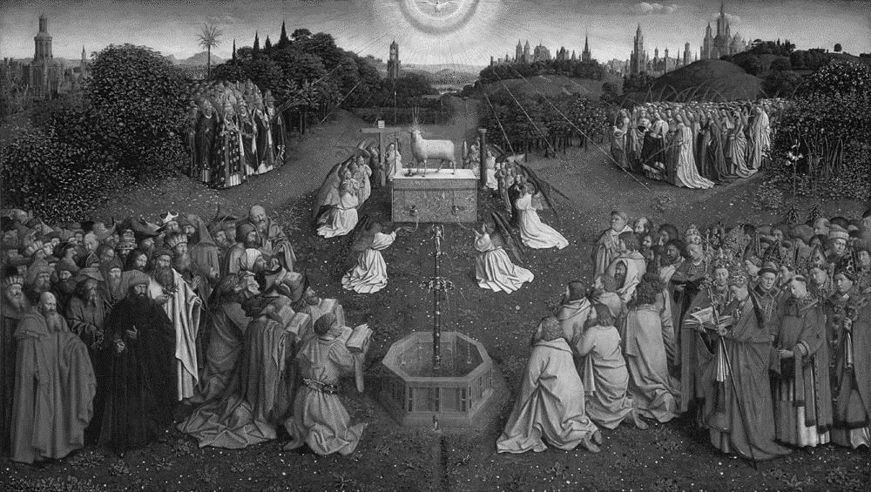

Adoration of the Mystic Lamb, Hubert and Jan van Eyck, panel painting in St. Bavo’s Cathedral, Ghent, Belgium, 1430

Please take a moment to silence your cell phones before the Mass begins.

The Music of the Mass: The Coronation Mass (K. 317) W. A. Mozart (1756–1791)
All stand at the bell.

Introit Antiphon Vocem jucunditatis annunciate et audiatur (Mode III)
With a voice of singing declare ye this, and let it be heard, alleluia; utter it even unto the ends of the earth: the Lord hath delivered his people, alleluia. Isaiah 48:20

Vidi Aquam Egredientem Mass Booklet, Pages 1 & 2

Kyrie Eleison Mass Booklet, Page 2

Gloria in Excelsis Deo Mass Booklet, Page 4

Collect of the Day
Celebrant The Lord be with you.
People And with thy spirit.
Celebrant Let us pray.
O God, who hast prepared for those who love thee such good things as pass man's understanding: Pour into our hearts such love toward thee, that we, loving thee in all things and above all things, may obtain thy promises, which exceed all that we can desire; through Jesus Christ our Lord, who liveth and reigneth with thee and the Holy Spirit, one God, for ever and ever. Amen.

First Lesson Acts 16:9–15
During the night Paul had a vision: there stood a man of Macedonia pleading with him and saying, “Come over to Macedonia and help us.” When he had seen the vision, we immediately tried to cross over to Macedonia, being convinced that God had called us to proclaim the good news to them. We set sail from Troas and took a straight course to Samothrace, the following day to Neapolis, and from there to Philippi, which is a leading city of the district of Macedonia and a Roman colony. We remained in this city for some days. On the sabbath day we went outside the gate by the river, where we supposed there was a place of prayer; and we sat down and spoke to the women who had gathered there. A certain woman named Lydia, a worshiper of God, was listening to us; she was from the city of Thyatira and a dealer in purple cloth. The Lord opened her heart to listen eagerly to what was said by Paul. When she and her household were baptized, she urged us, saying, “If you have judged me to be faithful to the Lord, come and stay at my home.” And she prevailed upon us.

Reader The Word of the Lord.
People Thanks be to God.

Psalm 67 Deus misereatur Chant: Jeffrey Smith (b. 1961)
Sung by the choir.

1 God be merciful unto us, and bless us,
and show us the light of his countenance, and be merciful unto us;
2 That thy way may be known upon earth,
thy saving health among all nations.
3 Let the peoples praise thee, O God;
yea, let all the peoples praise thee.
4 O let the nations rejoice and be glad;
for thou shalt judge the folk righteously, and govern the nations upon earth.
5 Let the peoples praise thee, O God;
yea, let all the peoples praise thee.
6 Then shall the earth bring forth her increase;
and God, even our own God, shall give us his blessing.
7 God shall bless us;
and all the ends of the world shall fear him.

The Epistle Revelation 21:10, 22–22:5
In the spirit the angel carried me away to a great, high mountain and showed me the holy city Jerusalem coming down out of heaven from God. I saw no temple in the city, for its temple is the Lord God the Almighty and the Lamb. And the city has no need of sun or moon to shine on it, for the glory of God is its light, and its lamp is the Lamb. The nations will walk by its light, and the kings of the earth will bring their glory into it. Its gates will never be shut by day-- and there will be no night there. People will bring into it the glory and the honor of the nations. But nothing unclean will enter it, nor anyone who practices abomination or falsehood, but only those who are written in the Lamb's book of life. Then the angel showed me the river of the water of life, bright as crystal, flowing from the throne of God and of the Lamb through the middle of the street of the city. On either side of the river is the tree of life with its twelve kinds of fruit, producing its fruit each month; and the leaves of the tree are for the healing of the nations. Nothing accursed will be found there any more. But the throne of God and of the Lamb will be in it, and his servants will worship him; they will see his face, and his name will be on their foreheads. And there will be no more night; they need no light of lamp or sun, for the Lord God will be their light, and they will reign forever and ever.

Subdeacon The Word of the Lord.
People Thanks be to God.

Hymn 398 I sing the almighty power Forest Green

Alleluia Verse Spiritus Sanctus docebit vos (Mode VIII)
Sung by the cantors, then repeated by all. After the cantors sing the verse, all repeat the Alleluia.

The Holy Ghost shall teach you: whatsoever I have said unto you. John 14:26

The Holy Gospel John 14:23–29
Deacon The Lord be with you.
People And with thy spirit.
Deacon The Holy Gospel of our Lord Jesus Christ according to John.
People Glory be to thee, O Lord.
Jesus said to Judas (not Iscariot), “Those who love me will keep my word, and my Father will love them, and we will come to them and make our home with them. Whoever does not love me does not keep my words; and the word that you hear is not mine, but is from the Father who sent me. I have said these things to you while I am still with you. But the Advocate, the Holy Spirit, whom the Father will send in my name, will teach you everything, and remind you of all that I have said to you. Peace I leave with you; my peace I give to you. I do not give to you as the world gives. Do not let your hearts be troubled, and do not let them be afraid. You heard me say to you, ‘I am going away, and I am coming to you.’ If you loved me, you would rejoice that I am going to the Father, because the Father is greater than I. And now I have told you this before it occurs, so that when it does occur, you may believe.”

Deacon The Gospel of the Lord.
People Praise be to thee, O Christ.

Sermon The Rev. Catherine Ballinger, OSB

The Nicene Creed Mass Booklet, Pages 6 & 7

The Prayers of the People Mass Booklet, Pages 8 & 9

The Peace Mass Booklet, Page 11

The Holy Communion

All sit, and the ushers come forward to collect the alms.

Didn’t bring cash this Sunday? St. Paul’s makes it easy to give online. Use the QR code at right to make a general contribution. Thank you for your generous support of our ministries!

Offertory Antiphon Benedicite, gentes, Dominum Deum nostrum (Tone II)
O bless the Lord our God, ye people; and make the voice of his praise to be heard: who holdeth our soul in life and suffereth not our feet to slip. Blessed be the Lord who hath not cast out my prayer : nor turned his mercy from me, alleluia.
Psalm 66:8–9,20

Offertory Motet

Ave, verum Corpus natum de Maria Virgine:
vere passum immolatum
in Cruce pro homine:
cujus latus perforatum unda fluxit sanguine:
esto nobis prægustatum in mortis examine.

Hail, true Body born of the Virgin Mary:
truly suffered, offered
on the Cross for humankind:
from whose pierced side poured forth blood:
be unto us a foretaste at the trial of death
Words: attributed to Innocent VI, ca. 1260; trans. 1992 by John H. Uhrig
Music: W. A. Mozart (K.V. 618)

All stand to sing the Offertory Hymn, and remain standing.

Hymn 212 Awake, arise, lift up your voice Richmond

Orate Mass Booklet, Page 11

Eucharistic Prayer D Mass Booklet, Page 12

Sanctus Et Benedictus Mass Booklet, Page 12

The Lord’s Prayer Mass Booklet, Page 14

The Fraction Mass Booklet, Page 15

Agnus Dei

Agnus Dei, qui tollis peccata mundi, miserere nobis.
Agnus Dei, qui tollis peccata mundi, miserere nobis.
Agnus Dei, qui tollis peccata mundi, dona nobis pacem.

O Lamb of God, that takest away the sins of the world, have mercy upon us.
O Lamb of God, that takest away the sins of the world, have mercy upon us.
O Lamb of God, that takest away the sins of the world, grant us thy peace.

All baptized Christians are welcome to receive the Eucharist at the Lord’s Table. If you are not receiving, you are invited to come forward for a blessing (indicated by crossing your arms over your chest). If you have not been baptized, and find yourself drawn to Jesus Christ and life in him, please let one of our clergy know. We would be honored to have a conversation with you about the possibility of baptism, or any other questions. Baptism and life in the Body of Christ are open to all.

Distribution of the chalice has been restored. However, intinction (dipping the bread into the chalice) is not permitted for health reasons. Thank you for your cooperation.

Communion Antiphon Spiritus Sanctus docebit vos (Mode VIII)
The Holy Ghost shall teach you: whatsoever I have said unto you. John 14:26

Hymn 512 Come, gracious Spirit Mendon

Post Communion Prayer Mass Booklet, Page 15

Easter Blessing Mass Booklet, Page 16

Dismissal Mass Booklet, Pages 16 & 17

Regina Cœli Easter Hymn

Celebrant Rejoice and be glad, O Virgin Mary, alleluia:
All For the Lord is risen indeed, alleluia.
Celebrant Let us pray. O God, who by the resurrection of thy Son Jesus Christ didst vouchsafe to give gladness unto the world: Grant, we beseech thee, that we, being holpen by the Virgin Mary his mother, may attain unto the joys of everlasting life; through the same Christ our Lord. Amen.

Hymn 345 Savior, again to thy dear name we raise Ellers

Voluntary Fantasia in F minor (K. 608) (Maestoso e Allegro) W. A. Mozart

  

Thank you for joining us this Sunday at St. Paul’s. We are privileged to have you with us and invite you to return and worship with us again.

Today we welcome members of Camerata of the University of Maryland Baltimore College under the direction of Dr. Stephen Caracciolo.

Our guest Organist and Choirmaster is Dr. Robbe Delcamp, formerly University Organist of The University of the South, Sewanee.

Parish Schedule: Sunday, May22nd – Sunday, May 29th, 2022
Sunday, May 22nd
The Sixth Sunday of Easter
5:30 a.m. Grate Patrol Delivery
9:00 a.m. Mass on the Grass, Parish Lawn
10:30 a.m. Solemn Mass, Nave

Monday, May 23rd
Vincent of Lerins, Priest
5:30 p.m. Shrine Prayers, Lady Altar
5:40 p.m. Evening Prayer, Angel
Chapel
6:00 p.m. Low Mass, Angel Chapel

Tuesday, May 24th
Jackson Kemper, First Missionary Bishop in the United States
9:45 a.m. Morning Prayer, Angel Chapel
10:00 a.m. Low Mass, Angel Chapel
6:00 p.m. Zoom Evening Prayer
7:00 p.m. Choir Rehearsal, Choir Room
& Nave

Wednesday, May 25th
Bede the Venerable Priest, and Monk of Jarrow
6:00 p.m. Zoom Evening Prayer

Thursday, May 26th
ASCENSION DAY
9:45 a.m. Morning Prayer, Angel Chapel
10:00 a.m. Low Mass, Angel Chapel
6:45 p.m. Procession and Solemn Mass,
Nave
7:00 p.m. AA Meeting,
Dining Hall

Friday, May 27th
Easter Feria
11:30 a.m. Grate Patrol Food Prep,
Dining Hall

Saturday, May 28th
Pachomius, Abbot
5:30 a.m. Grate Patrol Delivery
11:00 a.m. Holy Rosary, Angel Chapel
11:30 a.m. Low Mass, Angel Chapel

Sunday, May 29th
The Seventh Sunday of Easter: The Sunday After Ascension Day
5:30 a.m. Grate Patrol Delivery
9:00 a.m. Mass on the Grass, Parish Lawn
10:30 a.m. Solemn Mass, Nave

Parish Prayer List

In the Diocesan Cycle of Prayer, pray for: We pray for Church of the Ascension, Gaithersburg and Iglesia La Ascención; Church of the Ascension, Silver Spring; Church of the Ascension, Lexington Park; and St. Augustine’s Church, DC We pray also for congregations to engage in understanding their history in racial inequity.

In the wider Anglican Communion, pray for: Church of the Province of South East Asia; for Justin, Archbishop of Canterbury; Michael, the Presiding Bishop; and Mariann, our own bishop; for our sister parish St. Paul’s Knightsbridge, London; for the Episcopal Diocese of Jerusalem; the Georgetown Ministry Center; and the Bishop John T. Walker School for Boys.

For those who are sick or in need: especially Joseph, Gene, William, Carol, Thom, Gary, Gerry, Bill, Sharon, Martin, Russell, Devon, Benna, John, Chris, Michael, Joan, Grace, Lynn, Jim, Sui Mui, John, Martha, Justin, Gary, JoAnn, Alan, Connie, and Jenny.

For those who are traveling: James, Austin, Bill; Ernest and Ioana; John and Martha; and Kitty.

For a safe and healthy pregnancy for: Kelley.

We also give thanks for our visitors and newcomers and for the hospitality, evangelization, pastoral care, formation, and outreach our parishioners daily undertake.

SAINT PAUL’S PARISH
K Street — Washington, D.C.
St. Paul’s Parish seeks to restore all people to God and to each other,
through sacramental worship and Christ-like living.

2430 K Street, NW
Washington, D.C. 20037
phone 202-337-2020
web www.saintpaulskstreet.org
email office@stpauls-kst.com

The Rev’d Richard Wall, Rector
The Rev’d Catherine Ann Ballinger, OSB, Assistant Priest
The Reverends Tony Lewis, Elizabeth Orens, J. Peter Pham, Cameron Soulis,
and Joe Thompson, Assisting Priests
The Rev’d Ethan Bishop Henchman, Deacon
Jeffrey Smith, Director of Music
Dylan Thayer, Parish Coordinator

