Welcome! We are glad you are worshipping with us today. All baptized Christians are welcome to receive Holy Eucharist. An usher can provide a large-print Mass booklet, directions to our nursery, or an explanation of our worship customs. Please take a moment to silence your cell phones before the Mass begins.

This service follows the Mass Booklet, copies of which are found on the back of the pews along with the hymnals and the Book of Common Prayer.

The Music of the Mass: Missa secunda Hans Leo Hassler (1564-1612)

Voluntary Toccata in D minor, BWV 538a Johann Sebastian Bach (1685-1750)

All stand at the bell.

Introit Antiphon Terribilis est (Mode II)
O how dreadful is this place! This is none other than the house of God, and gate of heaven: and men shall call it the Palace of God. Cf. Genesis 28:17

The Solemn Procession

Procedamus in pace
Deacon Let us go forth in peace:
People In the Name of Christ. Amen.

Hymn 518 Christ is made the sure foundation (Westminster Abbey)

Station at the Font

Celebrant One Lord, one faith, one baptism, one God and Father of all:
People Who is above all, and through all, and in you all.
Celebrant Let us pray.
O Almighty God, who hast built thy Church upon the foundation of the Apostles and Prophets, Jesus Christ being the head cornerstone: Grant us so to be joined together in unity of spirit by their doctrine, that we may be made a holy temple acceptable unto thee; through the same Jesus Christ our Lord. Amen.

Hymn 360 Only begotten, Word of God eternal (Rouen)

Station at the Chancel Steps

Celebrant Blessed are they that dwell in thy house:
People They will be always praising thee.
Celebrant Let us pray.
O eternal Lord God, who hast preserved through the years this house built gloriously to thine honor: mercifully grant that we, with all who serve thee here in their generations, may be built up a spiritual house in the heavens, where thou art worshiped throughout all ages, world without end. Amen.

Celebrant Blessed be God, Father, Son, and Holy Spirit.
People And blessed be his kingdom, now and forever. Amen.

Kyrie eleison & Gloria in excelsis Mass Booklet, pages 1 & 2

Collect of the Day
Celebrant The Lord be with you.
People And with thy spirit.
Celebrant Let us pray.
O Almighty God, to whose glory we celebrate the dedication of this house of prayer: We give thee thanks for the fellowship of those who have worshiped in this place; and we pray that all who seek thee here may find thee, and be filled with thy joy and peace; through Jesus Christ our Lord, who liveth and reigneth with thee, in the unity of the Holy Spirit, one God, now and forever. Amen.

First Lesson Genesis 28:11–14

In those days: Jacob lighted upon a certain place, and tarried there all night, because the sun was set; and he took of the stones of that place, and put them for his pillows, and lay down in that place to sleep. And he dreamed, and behold a ladder set up on the earth, and the top of it reached to heaven: and behold the angels of God ascending and descending on it. And, behold, the Lord stood above it, and said, I am the Lord God of Abraham thy father, and the God of Isaac: the land whereon thou liest, to thee will I give it, and to thy seed; and thy seed shall be as the dust of the earth, and thou shalt spread abroad to the west, and to the east, and to the north, and to the south: and in thee and in thy seed shall all the families of the earth be blessed.

Reader The Word of the Lord.
People Thanks be to God.

Psalm 30:1-13 Exaltabo te, Domine Gerald Knight (1908-1979)
Sung by the choir.

1 I will magnify thee, O LORD, for thou hast set me up,
and not made my foes to triumph over me.
2 O LORD, my God, I cried unto thee;
and thou hast healed me.
3 Thou, LORD, hast brought my soul out of hell:
thou hast kept my life, that I should not go down into the pit.
4 Sing praises unto the LORD, O ye saints of his;
and give thanks unto him, for a remembrance of his holiness.
5 For his wrath endureth but the twinkling of an eye, and in his pleasure is life;
heaviness may endure for a night, but joy cometh in the morning.
6 And in my prosperity I said, I shall never be removed:
thou, LORD, of thy goodness, hast made my hill so strong.
7 Thou didst turn thy face from me,
and I was troubled.
8 Then cried I unto thee, O LORD;
and gat me to my LORD right humbly.
9 What profit is there in my blood,
when I go down into the pit?
10 Shall the dust give thanks unto thee?
or shall it declare thy truth?
11 Hear, O LORD, and have mercy upon me;
LORD, be thou my helper.
12 Thou hast turned my heaviness into joy;
thou hast put off my sackcloth, and girded me with gladness:
13 Therefore shall every good man sing of thy praise without ceasing.
O my God, I will give thanks unto thee for ever.

Epistle 1 Peter 2:1–9

Brethren: Laying aside all malice, and all guile, and hypocrisies, and envies, and all evil speakings, as newborn babes, desire the sincere milk of the word, that ye may grow thereby: if so be ye have tasted that the Lord is gracious. To whom coming, as unto a living stone, disallowed indeed of men, but chosen of God, and precious, ye also, as lively stones, are built up a spiritual house, an holy priesthood, to offer up spiritual sacrifices, acceptable to God by Jesus Christ. Wherefore also it is contained in the scripture, Behold, I lay in Sion a chief corner stone, elect, precious: and he that believeth on him shall not be confounded. Unto you therefore which believe he is precious: but unto them which be disobedient, the stone which the builders disallowed, the same is made the head of the corner, and a stone of stumbling, and a rock of offence, even to them which stumble at the word, being disobedient: whereunto also they were appointed. But ye are a chosen generation, a royal priesthood, an holy nation, a peculiar people; that ye should shew forth the praises of him who hath called you out of darkness into his marvellous light.

Reader The Word of the Lord.
People Thanks be to God.

Hymn 289 Our Father, by whose servants (Wolvercote)

Alleluia Adorabo ad templum (Mode II)
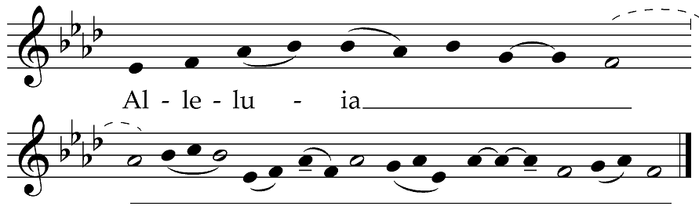
Sung by the cantors, then repeated by all. After the cantors sing the verse, all repeat the Alleluia.

V. I will worship toward thy holy temple: and praise thy name. Psalm 138:2

The Holy Gospel Matthew 7:13–14, 24–25

Deacon The Lord be with you.
People And with thy spirit.
Deacon The Holy Gospel of our Lord Jesus Christ according to Matthew.
People Glory be to thee, O Lord.

At that time: Jesus said: Enter ye in at the strait gate: for wide is the gate, and broad is the way, that leadeth to destruction, and many there be which go in thereat: because strait is the gate, and narrow is the way, which leadeth unto life, and few there be that find it. Therefore whosoever heareth these sayings of mine, and doeth them, I will liken him unto a wise man, which built his house upon a rock: and the rain descended, and the floods came, and the winds blew, and beat upon that house; and it fell not: for it was founded upon a rock.

Deacon The Gospel of the Lord.
People Praise be to thee, O Christ.

The Sermon The Reverend Richard Wall

Nicene Creed Mass Booklet, pages 4 & 5

Prayers of The People, Form I Mass Booklet, page 6

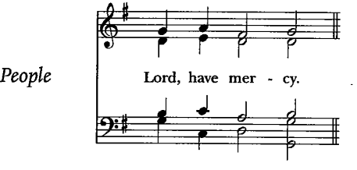  After each petition, the people sing | 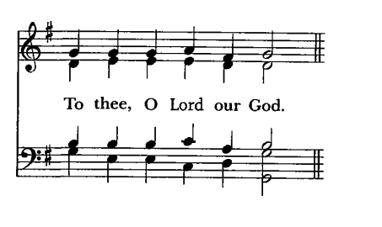  At the conclusion, the Deacon sings, “… and all our life to Christ, our God,” after which all respond

The Confession of Sin Mass Booklet, page 8

The Peace Mass Booklet, page 9

Liturgy of the Eucharist

The Holy Communion
All sit, and the ushers come forward to collect the alms.

Didn’t bring cash this Sunday? St. Paul’s makes it easy to give online. Use the QR code at right to make a general contribution. Thank you for your generous support of our ministries!

Offertory Antiphon Domine Deus, in simplicitate (Tone II)
O Lord God, in the uprightness of my heart I have willingly offered all these things; and now I have seen with joy thy people which are present here. O Lord God of Israel, keep for ever this imagination of the heart of thy people.
1 Chronicles 29:16–18

Offertory Motet Anton Bruckner (1824-1896)

Locus iste a Deo factus est, inæstimabile sacramentum, irreprehensibilis est.

This place was made by God, a priceless mystery, it is without reproof.
Part 1 of the Gradual for the Feast of the Dedication of a Church

Orate Fratres Mass Booklet, page 10

Sanctus & Benedictus Mass Booklet, page 14

Eucharistic Prayer I Mass Booklet, pages 14–16

The Lord’s Prayer Mass Booklet, page 16

Ecce Agnus Dei Mass Booklet, page 17

Agnus Dei Mass Booklet, page 17

All baptized Christians are welcome to receive the Eucharist at the Lord’s Table. If you are not receiving, you are invited to come forward for a blessing (indicated by crossing your arms over your chest). If you have not been baptized, and find yourself drawn to Jesus Christ and life in him, please let one of our clergy know. We would be honored to have a conversation with you about the possibility of baptism, or any other questions. Baptism and life in the Body of Christ are open to all.

Distribution of the chalice has been restored. However, intinction (dipping the bread into the chalice) is not permitted for health reasons. Thank you for your cooperation.

Communion Antiphon Domus mea (Mode V)
“My house shall be called a house of praise,” saith the Lord. There-in whosoever asketh shall receive, and he that seeketh shall find, and to him that knocketh it shall be opened.
Matthew 21:13; 7:8

Communion Anthem Leo Sowerby (1895-1968)

Eternal Light, shine into our hearts. Eternal Goodness, deliver us from evil. Eternal Power, be our support.
Eternal Wisdom, scatter the darkness of our ignorance. Eternal Pity, have mercy upon us. Through Jesus Christ our Lord. Amen.
St. Alcuin

Hymn 489 The great creator of the worlds (Tallis’ Ordinal)

Postcommunion Prayer Mass Booklet, page 17

Blessing Mass Booklet, page 18

Dismissal Mass Booklet, page 18

Hymn 680 O God, our help in ages past (St. Anne)

Voluntary Fugue in D minor, BWV 538b Bach

  

Thank you for joining us this Sunday at St. Paul’s. We are privileged to have you with us and invite you to return and worship with us again.

Parish Schedule: Sunday, October 2nd – Sunday, October 9th, 2022
Sunday, October 2nd
The Feast of the Dedication
6:00 a.m. Grate Patrol Delivery
10:00 a.m. Solemn Mass, Nave
11:30 a.m. Parish Luncheon, Parish Hall
4:00 p.m. Evensong & Benediction,
Nave

Tuesday, October 4th
Francis of Assisi, Friar
9:45 a.m. Morning Prayer, Angel Chapel
10:00 a.m. Low Mass, Angel Chapel
10:45 a.m. Rector’s Book Study, Clergy Office
4:45 p.m. Chorister Rehearsal, Choir Room & Nave
6:00 p.m. Zoom Evening Prayer

Wednesday, October 5th
Feria
5:30 p.m. Shrine Prayers, Lady Altar
5:40 p.m. Evening Prayer, Angel Chapel
6:00 p.m. Low Mass, Angel Chapel
7:00 p.m. Zoom Faith Formation

Thursday, October 6th
William Tyndale, Priest
Bruno, Founder of the Carthusians
9:45 a.m. Morning Prayer, Angel Chapel
10:00 a.m. Low Mass, Angel Chapel
4:45 p.m. Chorister Rehearsal (Probationers only), Choir Room & Nave
7:00 p.m. Parish Choir Rehearsal, Choir Room & Nave
7:00 p.m. AA Meeting, Dining Hall

Friday, October 7th
Holy Rosary of the Blessed Virgin Mary
11:30 a.m. Grate Patrol Food Prep,
Dining Hall

Saturday, October 8th
Blessed Virgin Mary
6:00 a.m. Grate Patrol Delivery
10:00 a.m. Blessing of the Animals
11:00 a.m. Holy Rosary, Lady Altar
11:30 a.m. Low Mass, Angel Chapel
1:00 p.m. Franciscan Monastery of the
Holy Land Pilgrimage

Sunday, October 9th
The Eighteenth Sunday after Pentecost
6:00 a.m. Grate Patrol Delivery
9:00 a.m. Mass, Nave
10:30 a.m. Solemn Mass, Nave

Notice of the Annual Meeting

St. Paul's Annual Meeting will be held on Wednesday, December 14, 2022, at 6:45pm in the Parish Hall.

Parish Prayer List

In the Diocesan Cycle of Prayer, pray for: St. Francis Church, Potomac. We pray for humane treatment of all of God’s creatures, especially companion, rescue, and service animals. Finally, we pray that all members of our congregations deepen their faith through prayer, spiritual direction, or other faith practices.

In the wider Anglican Communion, pray for: The Anglican Church of Canada; for Justin, Archbishop of Canterbury; Michael, the Presiding Bishop; and Mariann, our own bishop; for our sister parish St. Paul’s Knightsbridge, London; for the Episcopal Diocese of Jerusalem; the Georgetown Ministry Center; and the Bishop John T. Walker School for Boys.

For those who are sick or in need: especially Joseph, Gene, William, Carol, Thom, Gary, Gerry, Bill, Sharon, Martin, Russell, Devon, Benna, Chris, Michael, Joan, Grace, Lynn, Jim, Alan, Peggy, Jillian, Steven, James, Pamela, Laureen, Brian, Gary, JoAnn, Javier, Bob, Bette, Philip, and Bunny.

We also give thanks for our visitors and newcomers and for the hospitality, evangelization, pastoral care, formation, and outreach our parishioners daily undertake.

SAINT PAUL’S PARISH
K Street — Washington, D.C.
St. Paul’s Parish seeks to restore all people to God and to each other,
through sacramental worship and Christ-like living.

2430 K Street, NW
Washington, D.C. 20037
phone 202-337-2020
web www.saintpaulskstreet.org
email office@stpauls-kst.com

The Rev’d Richard Wall, Rector
The Rev’d Catherine Ann Ballinger, OSB, Assistant Priest
The Reverends Tony Lewis, Elizabeth Orens, J. Peter Pham, and Joe Thompson, Assisting Priests
The Rev’d Ethan Bishop Henchman, Deacon
Monica Berney, Interim Director of Music
Dylan Thayer, Parish Coordinator

