2023 Annual Giving Campaign
Dear friends,

This year began with Omicron, followed by navigating yet more new terrain in this (post) COVID world. But Anglo-Catholicism is tenacious: throughout it all we gather at the Altar. We continue to live and thrive in a different world, never quite knowing what tomorrow might bring. This is a liminal year, yet liminal does not mean inert: this is a year of excitement and hope, fresh perspectives and new focus.

This year’s Annual Giving theme, See, I Am Doing a New Thing, comes from the prophet Isaiah, and speaks of God always doing something new: for Scripture teaches that unexpected moments bring holy opportunities for God’s people. In 2022 we assumed responsibility for an Afghan refugee family; continued new focus on our community and neighbors through Tending Our Soil; started to examine our HVAC, parish hall, and kitchen in light of the needs of the future; and underwent a truly exciting transition in music. In November we celebrate a major anniversary by welcoming our Presiding Bishop and send a large group of parishioners on a Holy Land pilgrimage. This is all in addition to the regular rhythm of Anglo-Catholic parish ministry: the heartbeat of prayer, sacrifice, formation, pastoral care and love of the homeless and hungry that form the foundation on which we live and breathe. These are visible signs of the Incarnation continuing in our midst, our parish mission continuing strong – and all made possible through your financial support for our church.

Our vitality depends on your stewardship: your cheerful and generous offering of time, talent, and treasure. We ask you to consider making a financial pledge so St Paul’s can continue our unique call. We have a special and distinct witness, both locally and nationally; stewardship of this place we name home and these beloved traditions rests in our hands. With your support, we will see the ways in which God is doing a new thing.

Unlike some sister churches, we have no large endowment on which to rely. Your financial support is crucial to the work of our church, and especially in this climate of inflation. Stewardship season is a moment for our parish family to stand together. Please prayerfully consider making a pledge: your support will allow us to continue strong in a time that is undoubtedly challenging for all churches.

Included with this mailing is a pledge card for 2023. We hope that you will join others in our congregation and make a financial pledge by Sunday, October 30th, as, in faith, we continue walking toward God’s preferred future. If you have any questions or would like to further discuss making a financial pledge, please don’t hesitate to get in touch.

Faithfully,
Fr. Richard Wall Scott Spaulding
Rector Senior Warden

Some Frequently Asked Questions About Pledging
What is a stewardship pledge? A stewardship pledge is a commitment, made after deliberate and prayerful consideration, to contribute a specific amount of money to the parish community. It reflects the giver’s gratitude for God’s abundant grace in his or her life. Pledging enables the Vestry to make realistic budget projections for the coming calendar year. We hope that all members of St. Paul’s will contribute to the church with a stewardship pledge – even if it is only a small amount per week.

Is there a minimum pledge I have to give to be a member at St. Paul’s? No. All gifts, great or small, are received with gratitude.

What if I am not in a position to pledge right now? If you cannot contribute financially, you are still welcome at St. Paul’s. Remember too that gifts of your time and talent are valued and important expressions of stewardship. Volunteers are vital to ensure our ministries function properly. Please contact the clergy or staff to determine how you can pitch in.

How can I pay my pledge? You may make your pledge contribution by cash or check, by recurring or one-time online payments (credit, debit or ACH) at saintpaulskstreet.org/stewardship, or by a gift of securities.

Are gifts to St. Paul’s tax-deductible? Yes. Any contributions to St. Paul’s are tax-deductible to the fullest extent permitted under federal and state law.

How much should I pledge? Only you and God can answer that question, but there are some points of guidance. First, Jesus teaches us that giving regularly and generously is a spiritual virtue, and that only once we have entrusted God with our finances does He truly gain possession of our hearts (Matthew 6:19–24). The ancient Israelite pledge was 10%, which has survived into the modern practice of tithing (Deuteronomy 14:22). We encourage you to give as generously as you can, while remembering that no gift is too small to be appreciated.

What if I pledge and my circumstances change? A pledge is not a binding contract between you and St. Paul’s. Rather, a pledge is a spiritual commitment that represents a best estimate of what you intend to give in the coming year. It can be revised at any time without guilt or obligation. You can also increase your pledge if your financial situation improves.

Whom can I talk to about my pledge? If you have questions about the specifics of your pledge, ways to make pledge contributions, or other financial concerns, contact Katherine Britton, St. Paul’s Treasurer, at treasurer@stpauls-kst.com. If you have questions about the spiritual dimensions of pledging, please contact Fr. Richard Wall at wall@stpauls-kst.com. Any conversations about any aspect of pledging will be kept strictly confidential.

St. Paul’s in 2022: What We Did with God
Over the past twelve months, Christ invited us to follow Him along paths that we have never before trod, and also encouraged us to reconnect with our familiar obligations to Himself and to each other. Here’s what we did, with God’s help, in 2022:

Afghan Refugee Ministry In August of 2021, a group of parishioners, alarmed by the humanitarian crisis in Afghanistan, formed a working group to consider ways that our parish could help. With guidance from clergy and lay people both inside our parish and across the Diocese, the team decided to sponsor an Afghan family who had recently immigrated to the United States. Our sponsored family moved into their apartment in Fairfax, VA, this past May. The parish raised over $30,000 to support the Afghan Refugee Ministry, and over 30 parishioners and other volunteers have devoted countless hours to supporting our family. Scripture reminds us to love newcomers as we love ourselves (Leviticus 19:34). With God’s help, we extended Christ’s love to our neighbors in a completely different way in 2022.

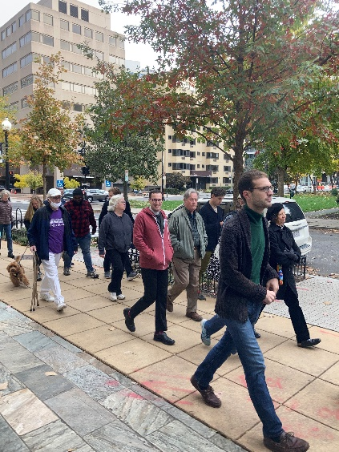
Tending Our Soil Our efforts to bless those outside our walls in new ways did not end with the Afghan Refugee Ministry. Beginning last September, St. Paul’s began a three-year journey in the Diocese’s Tending Our Soil initiative. This initiative is designed to help parishes shift their focus outward and prayerfully consider how God is calling them to minister to their neighbors. A committee of clergy, staff, and lay people are considering how St. Paul’s can most effectively witness Christ’s love in our distinct local context. Many parishioners are joining us in this work: by walking around the parish boundaries, sharing favorite St. Paul’s memories, and assessing St. Paul’s ministries openly, honestly, and with great affection. The support of our parish family was essential in helping the team craft its two goals for 2023: first, to relaunch a new and improved Welcoming Ministry, and second, to host meetings with strategic community partners, with an invitation for a community breakfast around mid-January.
St. Paul’s parishioners walking the parish boundaries
Building and Grounds One of the great realizations of Tending Our Soil is that our building must change to meet the changing ministry needs of our neighborhood. Currently, we are carefully evaluating our kitchen and other areas of Pillsbury House to determine what new things God is calling us to do, and the tools we need to do them. We also renovated our parish columbarium and added a standing bench with an additional 60 niches.

Music In June, we said goodbye to Jeffrey Smith, who transitioned to a professorial role at Indiana University. Our new Interim Director of Music, Monica Berney, is energizing the choir, choristers, and congregation, and we are thrilled to see what new things will happen in the music ministry in 2023.

Grate Patrol For the first time since the pandemic began, Grate Patrol was able to resume Saturday and Sunday morning service in 2022. Grate Patrol also expanded its ability to provide clothing and other essential items to those out on the streets. Although this ministry is not new, the challenges we faced were –and with the help of so many people inside and outside the parish, we were able to meet those challenges.

We at St. Paul’s are extraordinarily grateful for your generous support, and the support of so many others like you in our parish.

See, I Am Doing a New Thing
The next two months will see an incredible flurry of new things at St. Paul’s.

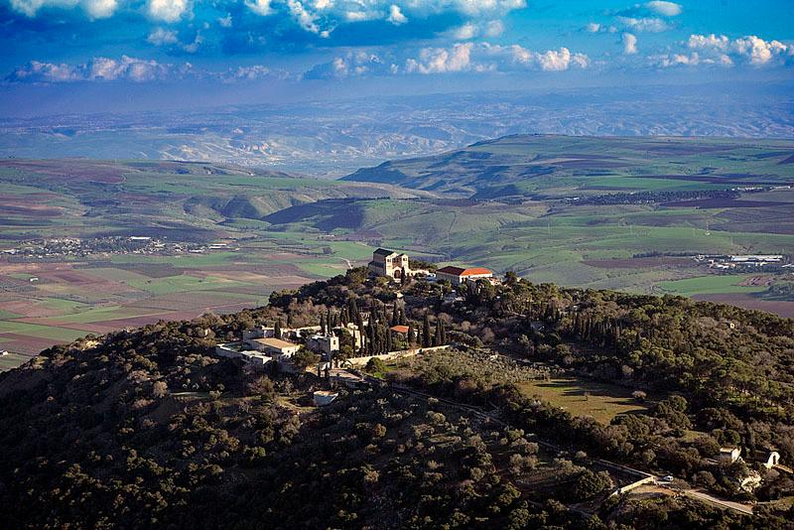
We begin October with a Feast of the Dedication to celebrate another year of our parish’s faithful service and witness to Christ (Sunday, October 2nd). During October, we will prepare ourselves as a parish for the new journey God is asking us to take inward and outward on our spiritual pilgrimage. We will take a parish field trip to the Franciscan Monastery of the Holy Land in America (Saturday, October 8th) and enjoy a book study hosted by Fr. Richard (October 4th, 11th, and 18th) as well as a Zoom Formation series featuring the once and future Professor Ian Boxall, who will discuss the life of Jesus (October 5th, 12th, 19th, and 26th). We are also preparing a special party for new members of the parish, which will be hosted off site after the 10:30am Mass on Sunday, October 30th.
The Holy Land

All of this is in preparation for November’s sequence of celebration: the feasts of All Saints and All Souls, followed quickly by our parish pilgrimage to the Holy Land (November 7th – 17th). The month concludes with Advent Lessons and Carols, followed by a jubilee Evensong and Benediction honoring the 50th anniversary of Fr. Tony Lewis’ ordination, with Presiding Bishop Michael Curry preaching (November 30th). All this excitement before 2023 has even begun! We hope to see you for as much of the festivities as possible.

The year 2023 promises to be a truly exhilarating one, with ample opportunities for everyone in our parish to embark on new journeys and take on new challenges in our communal life with Christ. We ask each of you to prayerfully consider where God is calling you in the invaluable work of building His Kingdom over the coming year.

God is doing so many new things in our midst.

We hope that you will join Him – and us – this year and beyond.

