SAINT PAUL’S PARISH

K Street – Washington, D.C.

**An Advent Procession with Lessons and Carols 2022**

Welcome! We are glad you are worshipping with us this evening. If you are a visitor, we invite you to sign our guest register and to fill out a Visitor Card, which may be found in the pews or available from a greeter. Please place the Visitor Card in the offering plate, or give it to a greeter or member of the clergy if you would like further information, or if you wish to speak with a priest. We invite you to return and worship with us again soon, and hope you will join us on Sunday for Mass (9:00 Mass, 10:30 Solemn Mass, or Solemn Evensong and Benediction at 4:00 p.m. on selected Sundays)

**Please take a moment to silence any electronic devices you may be carrying.**

**About this Service**

*This service begins in darkness. The Congregation is asked to review texts and rubrics before the service begins.*

Advent (the word means “coming” or “arrival”) is a season which has two meanings for Christians. It is a time to prepare for the anniversary of the Lord Jesus’ first coming—his birth to the Blessed Virgin Mary at Bethlehem two thousand years ago—and culminates in our celebration of Christmas, the twelve-day feast that lasts from December 25 to January 6. The other theme of Advent is the Second Coming of Our Lord at the end of time, when he will come in great power and glory to judge both the living and the dead. The double emphasis on both the first and the second advents of Christ gives to the season its unique mixture of devotional joy—joy in the redemption that has come to us in the Incarnation, and awe before the Judgment that yet awaits us.

To the spiritually discerning believer, both of these tremendous and signal events of past and future are experienced as eternally present realities. The Procession with Carols on Advent Sunday originated at King’s College, Cambridge, England in 1934, composed by Dean Eric Milner-White (who had also been responsible nine years earlier for the more widely known Festival of Nine Lessons and Carols for Christmas Eve). In his Preface to the Advent Sunday service, Dean Milner-White wrote: “In the old English liturgies, the Advent Offices made a preparation for the coming of our Lord to this earth far more vivid and eager than those of our present Prayer Book. So an Advent Carol Service, if without precedent, is not without suitability, if it helps to express ‘the desire of all nations and ages.’” The purpose of the service is “not to celebrate Christmas, but to expect it.”

The progression of the choir, starting in darkness at the back of the church and ending in brilliant light at the High Altar, symbolizes the movement from the prophetic expectation of Messiah to the very brink of messianic fulfillment, both in the birth of the Son of God and his final coming in judgment and glory. We are bidden to awake and watch, prepare and expect, for our God will come and save us, and deliver us from the bondage of sin and death, and bring us into the radiance of his kingdom of glory.

*The service follows the order in this booklet.*

*The Choir and Ministers assemble in the atrium. At the sound of the bell, the Congregation stands.*

**Matin Responsory** *Aspiciens a longe*

*Sung by the Choir.*

V. I look from afar:

R. And lo, I see the power of God coming, and a cloud covering the whole earth.

V. Go ye out to meet him and say:

R. Tell us, art thou he that should come to reign over thy people Israel?

V. High and low, rich and poor, one with another,

R. Go ye out to meet him and say:

V. Hear, O thou Shepherd of Israel, thou that leadest Joseph like a sheep,

R. Tell us, art thou he that should come?

V. Stir up thy strength, O Lord, and come:

R. To reign over thy people Israel.

Glory be to the Father, and to the Son, and to the Holy Ghost.

V. I look from afar:

R. And lo, I see the power of God coming, and a cloud covering the whole earth.

V. Go ye out to meet him and say:

R. Tell us, art thou he that should come to reign over thy people Israel?

*Words: Responsory I, Matins of Advent*

*Music: Adapted from G.P. da Palestrina (1525–1594)*

*The Ministers and Readers proceed to their places.*

**Hymn** *Veni, Redemptor gentium*

*Sung by the Choir.*

Come, thou Redeemer of the earth, and manifest thy Virgin-birth:

Let every age adoring fall, such birth befits the God of all.

Begotten of no human will, but of the Spirit, thou art still

The Word of God in flesh arrayed, the promised fruit to man displayed.

From God the Father he proceeds, to God the Father back he speeds;

His course he runs to death and hell, returning on God’s throne to dwell.

O equal to thy Father, thou! Gird on thy fleshly mantle now;

The weakness of our mortal state with deathless might invigorate.

Thy cradle here shall glitter bright, and darkness breathe a newer light,

Where endless faith shall shine serene, and twilight never intervene.

All laud, eternal Son, to thee whose advent sets thy people free,

Whom with the Father we adore, and Holy Ghost, for evermore.

*Words: Verses 1–5 of a hymn by Saint Ambrose (340–397)*

*Music:* Puer nobis*, melody adapted by Michael Praetorius (1571–1621), harmonized by G. R. Woodward (1848–1934)*

**The Bidding Prayer**

*Led by the Officiant.*

Beloved in Christ, as we await the great festival of Christmas, let us prepare ourselves so that we may be shown its true meaning. Let us hear, in lessons from Holy Scripture, how the prophets of Israel foretold that God would visit and redeem his waiting people. Let us rejoice, in our carols and hymns, that the good purpose of God is being mightily fulfilled. Let us celebrate the promise that our Lord and Savior, Jesus Christ, will bring all people and all things into the glory of God’s eternal kingdom. The blind receive their sight, and the lame walk, the lepers are cleansed, and the deaf hear, the dead are raised up, and the poor have the Gospel preached to them.

But first, let us pray for the world which God so loves, for those who have not heard the good news of God, or who do not believe it; for those who walk in darkness and the shadow of death; and for the Church in this place and everywhere, that it may be freed from all evil and fear, and may in pure joy lift up the light of the love of God. These prayers and praises let us humbly offer to God, in the words which Christ himself taught us:

*People* Our Father, who art in heaven, hallowed be thy name, thy kingdom come, thy will be done, on earth as it is in

heaven. Give us this day our daily bread. And forgive us our trespasses, as we forgive those who trespass against us. And lead us not into temptation, but deliver us from evil. For thine is the kingdom, and the power, and the glory; for ever and ever. Amen.

*The Congregation sits.*

**Invitatory**

*Sung by the Choir.*

*Rorate caeli desuper, et nubes pluant justum:*

*aperiatur terra, et germinet salvatorem.  
Benedixisti, Domine, terram tuam:*

*avertisti captivitatem Jacob.  
Gloria Patri, et Filio, et Spiritui Sancto.*

*Sicut erat in principio, et nunc, et semper,*

*et in saecula saeculorum. Amen.*

Drop down ye heavens, from above, and let the skies pour down righteousness:

Let the earth open and bring forth a Saviour.  
Lord, thou hast blessed thy land:

Thou hast turned away the captivity of Jacob.  
Glory be to the Father, and to the Son, and to the Holy Ghost. As it was in the beginning, is now,

and ever shall be, world without end. Amen.

*Words: Advent Prose (Rorate cœli desuper), 4th cent.*

*Music: William Byrd (1543-1623)*

**First Lesson**  Zechariah 2:10–13

*The Lord promises that the King will come to Israel in peace.*

Sing and rejoice, O daughter of Zion: for, lo, I come, and I will dwell in the midst of thee, saith the Lord. And many nations shall be joined to the Lord in that day, and shall be my people: and I will dwell in the midst of thee, and thou shalt know that the Lord of hosts hath sent me unto thee. And the Lord shall inherit Judah his portion in the holy land, and shall choose Jerusalem again.Be silent, O all flesh, before the Lord: for he is raised up out of his holy habitation.

*Reader* The Word of the Lord.

*People* Thanks be to God.

**Anthem***Sung by the Choir.*

Christ, he requires still wheresoe’er he comes,

to feed or lodge, to have the best of rooms:

Give him the choice;

grant him the nobler part of all the house:

the best of all’s the heart.

*Words: Robert Herrick (1591-1674) in his Noble Numbers, 1647*

*Music: Randall Thompson (1899-1984)*

**Hymn**

*The Congregation remains seated and sings the refrain.*

O come, O come, Emmanuel, and ransom captive Israel,

That mourns in lowly exile here until the Son of God appear.

**People** *Rejoice! Rejoice! Emmanuel shall come to thee, O Israel.*

O come, thou Wisdom from on high, who orderest all things mightily;   
To us the path of knowledge show, and teach us in her ways to go.

*Rejoice! Rejoice! Emmanuel shall come to thee, O Israel.*

O come, O come, thou Lord of might, who to thy tribes on Sinai’s height  
In ancient times didst give the law, in cloud, and majesty, and awe.

*Rejoice! Rejoice! Emmanuel shall come to thee, O Israel.*

O come, thou branch of Jesse’s tree, free them from Satan’s tyranny  
That trust thy mighty power to save, and give them victory o’er the grave.

*Rejoice! Rejoice! Emmanuel shall come to thee, O Israel.*

O come, thou Key of David, come, and open wide our heavenly home;   
Make safe the way that leads on high, and close the path to misery.

*Rejoice! Rejoice! Emmanuel shall come to thee, O Israel.*

O come, thou Dayspring from on high, and cheer us by thy drawing nigh;   
Disperse the gloomy clouds of night, and death’s dark shadows put to flight.

*Rejoice! Rejoice! Emmanuel shall come to thee, O Israel.*

O come, Desire of nations, bind in one the hearts of all mankind;   
Bid thou our sad divisions cease, and be thyself our King of peace.

*Rejoice! Rejoice! Emmanuel shall come to thee, O Israel.*

O come, O come, Emmanuel, and ransom captive Israel,

That mourns in lowly exile here until the Son of God appear.

*Rejoice! Rejoice! Emmanuel shall come to thee, O Israel.*

*Words: The Great “O” Antiphons of Advent, Latin, 9th century*

*Music:* Veni, veni Emmanuel, *15th century French Franciscan processional; ed. Mary Berry, 1966*

**Second Lesson** Isaiah 11:1–10

*The Spirit of the Lord will rest upon the Holy One.*

And there shall come forth a rod out of the stem of Jesse, and a Branch shall grow out of his roots: And the spirit of the Lord shall rest upon him, the spirit of wisdom and understanding, the spirit of counsel and might, the spirit of knowledge and of the fear of the Lord; And shall make him of quick understanding in the fear of the Lord: and he shall not judge after the sight of his eyes, neither reprove after the hearing of his ears: But with righteousness shall he judge the poor, and reprove with equity for the meek of the earth: and he shall smite the earth: with the rod of his mouth, and with the breath of his lips shall he slay the wicked. And righteousness shall be the girdle of his loins, and faithfulness the girdle of his reins. The wolf also shall dwell with the lamb, and the leopard shall lie down with the kid; and the calf and the young lion and the fatling together; and a little child shall lead them. And the cow and the bear shall feed; their young ones shall lie down together: and the lion shall eat straw like the ox. And the sucking child shall play on the hole of the asp, and the weaned child shall put his hand on the cockatrice’ den. They shall not hurt nor destroy in all my holy mountain: for the earth shall be full of the knowledge of the Lord, as the waters cover the sea. And in that day there shall be a root of Jesse, which shall stand for an ensign of the people; to it shall the Gentiles seek: and his rest shall be glorious.

*Reader* The Word of the Lord.

*People* Thanks be to God.

**Anthem**

*Sung by the Choir.*

Never weather-beaten sail more willing bent to shore.

Never tired pilgrim's limbs affected slumber more,

Than my wearied sprite now longs to fly out of my troubled breast:

O come quickly, sweetest Lord, and take my soul to rest.

Ever blooming are the joys of Heaven's high Paradise.

Cold age deafs not there our ears nor vapour dims our eyes:

Glory there the sun outshines whose beams the blessed only see:

O come quickly, glorious Lord, and raise my sprite to thee!

*Words: Thomas Campion (1567-1620), from his “Two Bookes of Ayres, The First Contayning Divine and Morall Songs,” ca. 1612–1613  
Music: Richard Shephard (1949-2021)*

**Third Lesson** Isaiah 40:1–8

*The Prophet proclaims good news to the people in exile.*

Comfort ye, comfort ye my people, saith your God.Speak ye comfortably to Jerusalem, and cry unto her, that her warfare is accomplished, that her iniquity is pardoned: for she hath received of the Lord’s hand double for all her sins.The voice of him that crieth in the wilderness, Prepare ye the way of the Lord, make straight in the desert a highway for our God.Every valley shall be exalted, and every mountain and hill shall be made low: and the crooked shall be made straight, and the rough places plain:And the glory of the Lord shall be revealed, and all flesh shall see it together: for the mouth of the Lord hath spoken it.The voice said, Cry. And he said, What shall I cry? All flesh is grass, and all the goodliness thereof is as the flower of the field:The grass withereth, the flower fadeth: because the spirit of the Lord bloweth upon it: surely the people is grass.The grass withereth, the flower fadeth: but the word of our God shall stand for ever.

*Reader* The Word of the Lord.

*People* Thanks be to God.

*The Congregation stands.*

**Hymn**

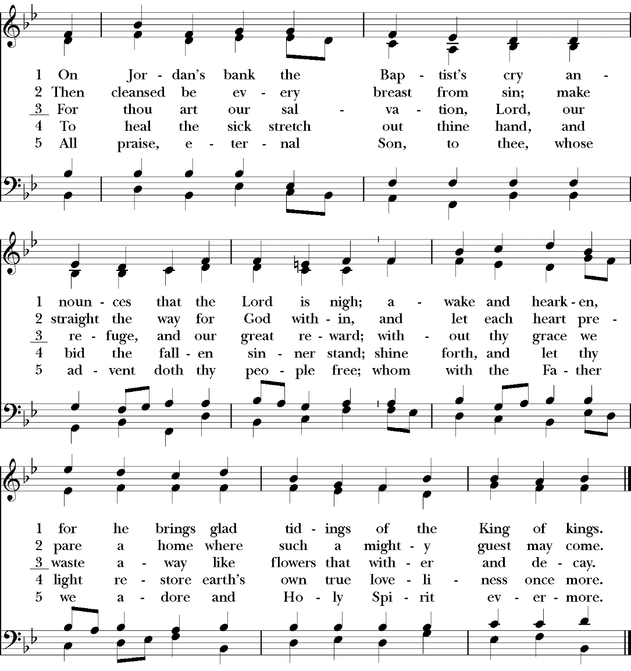*Sung by All. Stanzas 1, 2, and 5 are sung in unison.*

*Words: Charles Coffin (1676–1749), founded on Isaiah 40:3 and Matthew 3:3*

*Music:* Winchester New*, from* Musicalisches Hand-Buch, *Hamburg 1690*

*The Congregation sits.*

**Carol***Sung by the Choir.*

Comfort, comfort ye my people, speak ye peace, thus saith our God;

Comfort those who sit in darkness mourning ‘neath their sorrows’ load

Speak ye to Jerusalem of the peace that waits for them;

Tell her that her sins I cover, and her warfare now is over.

Hark, the voice of one that crieth in the desert far and near,

Calling us to new repentance since the kingdom now is here.

Oh, that warning cry obey!  Now prepare for God away;

Let the valleys rise to meet him and the hills bow down to greet him.

Make ye straight what long was crooked, make the rougher places plain;

Let your hearts be true and humble, as befits his holy reign.

For the glory of the Lord now o’er earth is shed abroad;

And all flesh shall see the token that the word is never broken.

*Words: Johann G. Olearius (1611-1694); tr. Catherine Winkworth (1827-1878)*

*Music: Claude Goudimel (c.1514-1572)*

**Fourth Lesson**  Baruch 4:36–5:9

*The scribe Baruch urges the people to look east because salvation is at hand.*

Look about thee, O Jerusalem, towards the east, and behold the joy that cometh to thee from God. For behold thy children come, whom thou sentest away scattered, they come gathered together from the east even to the west, at the word of the Holy One rejoicing for the honour of God. Put off, O Jerusalem, the garment of thy mourning, and affliction: and put on the beauty, and honour of that everlasting glory which thou hast from God. God will clothe thee with the double garment of justice, and will set a crown on thy head of everlasting honour. For God will shew his brightness in thee, to every one under heaven. For thy name shall be named to thee by God for ever: the peace of justice, and honour of piety. Arise, O Jerusalem, and stand on high: and look about towards the east, and behold thy children gathered together from the rising to the setting sun, by the word of the Holy One rejoicing in the remembrance of God. For they went out from thee on foot, led by the enemies: but the Lord will bring them to thee exalted with honour as children of the kingdom. For God hath appointed to bring down every high mountain, and the everlasting rocks, and to fill up the valleys to make them even with the ground: that Israel may walk diligently to the honour of God. Moreover the woods, and every sweet-smelling tree have overshadowed Israel by the commandment of God. For God will bring Israel with joy in the light of his majesty, with mercy, and justice, that cometh from him.

*Reader* The Word of the Lord.

*People* Thanks be to God.

**Anthem**

*Sung by the Choir.*

O sing unto the Lord a new song,

sing unto the Lord, all the whole earth.

Sing unto the Lord, and praise his name;

be telling of this salvation from day to day.

For he cometh, for he cometh to judge the earth;

and with righteousness to judge the world,

and the people with his truth.  

*Words:  Psalm 96:1, 2, 13*

*Music: James MacMillan (b. 1959)*

*The Congregation stands.*

**Hymn** *Vox clara ecce intonat*

*Sung by All.*

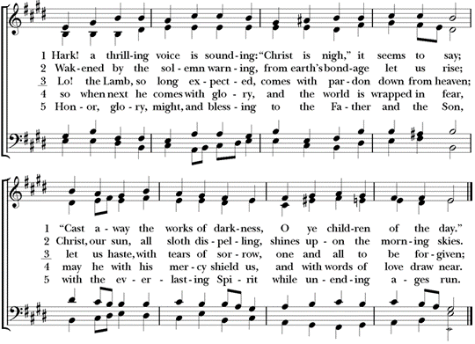

*Words: Latin, ca. 6th century, founded on Romans 13:11; recast 1628; tr. by the compilers of* Hymns Ancient and Modern, *1861, alt.,  
 chiefly based on Edward Caswall (1814–1878)*

*Music:* Merton*, William Henry Monk (1823–1889)*

*The Congregation sits.*

**Fifth Lesson** Luke 1:26–38

*The angel Gabriel salutes the Blessed Virgin Mary.*

And in the sixth month the angel Gabriel was sent from God unto a city of Galilee, named Nazareth, To a virgin espoused to a man whose name was Joseph, of the house of David; and the virgin’s name was Mary.And the angel came in unto her, and said, Hail, thou that art highly favoured, the Lord is with thee: blessed art thou among women.And when she saw him, she was troubled at his saying, and cast in her mind what manner of salutation this should be.And the angel said unto her, Fear not, Mary: for thou hast found favour with God.And, behold, thou shalt conceive in thy womb, and bring forth a son, and shalt call his name Jesus.He shall be great, and shall be called the Son of the Highest: and the Lord God shall give unto him the throne of his father David:And he shall reign over the house of Jacob for ever; and of his kingdom there shall be no end.Then said Mary unto the angel, How shall this be, seeing I know not a man?And the angel answered and said unto her, The Holy Ghost shall come upon thee, and the power of the Highest shall overshadow thee: therefore also that holy thing which shall be born of thee shall be called the Son of God.And, behold, thy cousin Elisabeth, she hath also conceived a son in her old age: and this is the sixth month with her, who was called barren.For with God nothing shall be impossible.And Mary said, Behold the handmaid of the Lord; be it unto me according to thy word. And the angel departed from her.

*Reader* The Word of the Lord.

*People* Thanks be to God.

**Anthem**

*Sung by the Choir.*

Mother of God, here I stand now praying.

Before this ikon of your radiant brightness,

not praying to be saved from a battlefield;

not giving thanks, nor seeking forgiveness for the sins of my soul,

nor for all the souls Numb, joyless and desolate on earth;

but for her alone, whom I wholly give you...

*Words: Based on a prayer by Mikhail Yuryevich Lermontov (1814-1842)  
Music: Sir John Tavener (1944-2013)*

****Hymn** *Sung by all.*

*Words: Martin Luther (1483-1546) after Ambrose of Milan (340-397); tr. William M. Reynolds (1812-1876) and James Waring McGrady (b. 1938)*

*Music:* Nun komm, der Heiden Heiland*, melody from* Erfurt Enchiridia *(1524)*

**Sixth Lesson** Jeremiah 31:31–34

*A new covenant is promised which will be written in our hearts.*

Behold, the days come, saith the Lord, that I will make a new covenant with the house of Israel, and with the house of Judah:Not according to the covenant that I made with their fathers in the day that I took them by the hand to bring them out of the land of Egypt; which my covenant they brake, although I was an husband unto them, saith the Lord:But this shall be the covenant that I will make with the house of Israel; After those days, saith the Lord, I will put my law in their inward parts, and write it in their hearts; and will be their God, and they shall be my people.And they shall teach no more every man his neighbour, and every man his brother, saying, Know the Lord: for they shall all know me, from the least of them unto the greatest of them, saith the Lord: for I will forgive their iniquity, and I will remember their sin no more.

*Reader* The Word of the Lord.

*People* Thanks be to God.

**Carol**

*Sung by the Choir.*

Tomorrow shall be my dancing day: I would my true love did so chance

to see the legend of my play, to call my true love to my dance.

*Refrain*  Sing, O my love, O my love, my love, my love; this have I done for my true love.

Then was I born of a virgin pure, of her I took fleshly substance;

thus was I knit to man's nature, to call my true love to my dance. *Refrain.*

In a manger laid and wrapped I was, so very poor this was my chance,

betwixt an ox and a silly poor ass, to call my true love to my dance. *Refrain.*

Then afterwards baptized I was; the Holy Ghost on me did glance,

my Father's voice heard from above, to call my true love to my dance. *Refrain.*

*Words: William B. Sandy (1792-1874)*Christmas Carols Ancient and Modern*(1833)*

*Music: adapted by John Gardner; Op. 75, No. 2 (1965)*

*The Congregation stands.*

**Hymn** *Sung by All.*

*Words: Charles Oakley (1832–1865) Music:* Little Cornard, *Martin Shaw (1875–1958)*

*The Congregation sits.*

*During the following, a collection is taken which will be designated for the support of the work and ministry of St. Paul’s Parish.*

**Carol**

Adam lay ybounden, bounden in a bond:

four thousand winter thoght he not too long.

and all was for an appil, an appil that he took,

as clerkes finden wreten in their book.

Ne hadde the appil taken ben,

ne hadde never our Lady a ben heavene quene.

Blessed be the time that appil taken was:

therefore we moun singen *Deo gracias*.

*Words: British Library Sloan MS. 2593, 15th cent.*

*Music: Frank Boles (b.1955)*

**Seventh Lesson**  Revelation 21:5–7; 22:12–13, 20

*Saint John unfolds the fulfillment of all creation.*

And he that sat upon the throne said, Behold, I make all things new. And he said unto me, Write: for these words are true and faithful.And he said unto me, It is done. I am Alpha and Omega, the beginning and the end. I will give unto him that is athirst of the fountain of the water of life freely.He that overcometh shall inherit all things; and I will be his God, and he shall be my son. And, behold, I come quickly; and my reward is with me, to give every man according as his work shall be.I am Alpha and Omega, the beginning and the end, the first and the last.He which testifieth these things saith, Surely I come quickly. Amen. Even so, come, Lord Jesus.

*Reader* The Word of the Lord.

*People* Thanks be to God.

*The Congregation stands.*

**Hymn**

*Sung by All. The first two stanzas are sung in harmony; the final stanza in unison.*

*Harmony*

*Harmony*

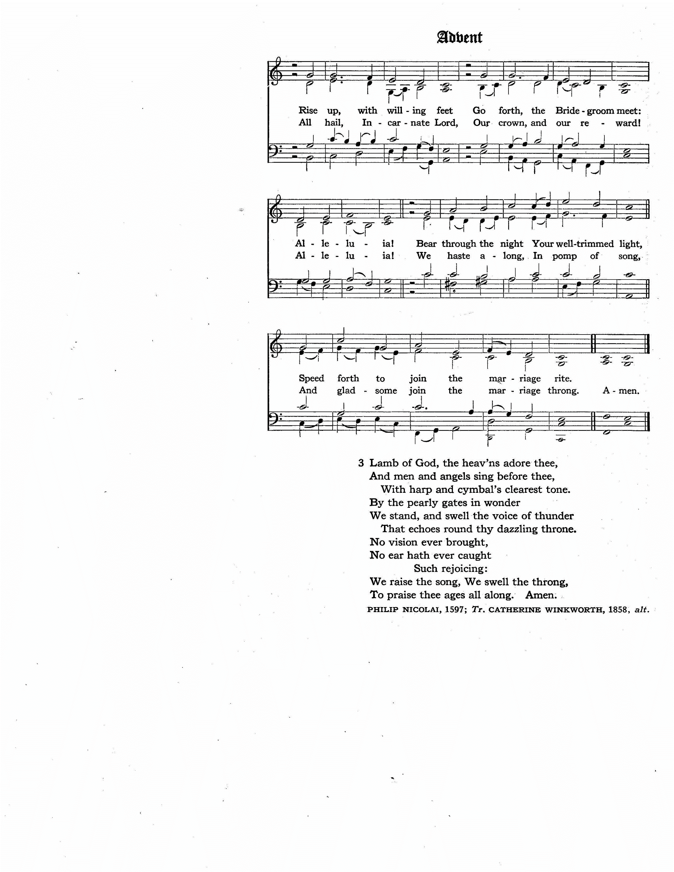

*Unison*

*Words: Philipp Nicolai (1566–1608), trans. Catherine Winkworth (1827–1878), alt.*

*Music:* Wachet auf, *arranged and harmonized by Johann Sebastian Bach (1685–1750)*

**Collect**

*Officiant* The Lord be with you.

*People* And with thy spirit.

*Officiant* Let us pray.

Almighty God, give us grace that we may cast away the works of darkness, and put upon us the armor of light, now in the time of this mortal life in which thy Son Jesus Christ came to visit us in great humility; that in the last day, when he shall come again in his glorious majesty to judge both the quick and the dead, we may rise to the life immortal; through him who liveth and reigneth with thee and the Holy Ghost, one God, now and for ever. *Amen.*

**Vesper Responsory**

*Sung by Choir.*

*V.* Judah and Jerusalem, fear not, nor be dismayed:

*R.* Tomorrow go ye forth and the Lord he will be with you.

*V.* Stand ye still, and ye shall see the salvation of our God:

*R.* Tomorrow go ye forth and the Lord he will be with you.

*V.* Glory be to the Father, and to the Son, and to the Holy Ghost:

*R.* Tomorrow go ye forth and the Lord he will be with you.

*Words: Responsory I, Matins of Advent*

*Music: Adapted from G.P. da Palestrina (1525–1594)*

*All kneel.*

**The Blessing**

Open wide, O Lord, the gates of heaven and visit thy people in peace; send forth thy Spirit from on high, that their hearts may be uplifted unto thee; O Lord, who for our sake wast of a virgin born, make holy thy people, and bless thine heritage. And the blessing of God Almighty, the Father, the Son and the Holy Ghost, be amongst you and abide with you for ever. *Amen.*

*The Congregation stands.*

**Hymn** *Sung by All.*

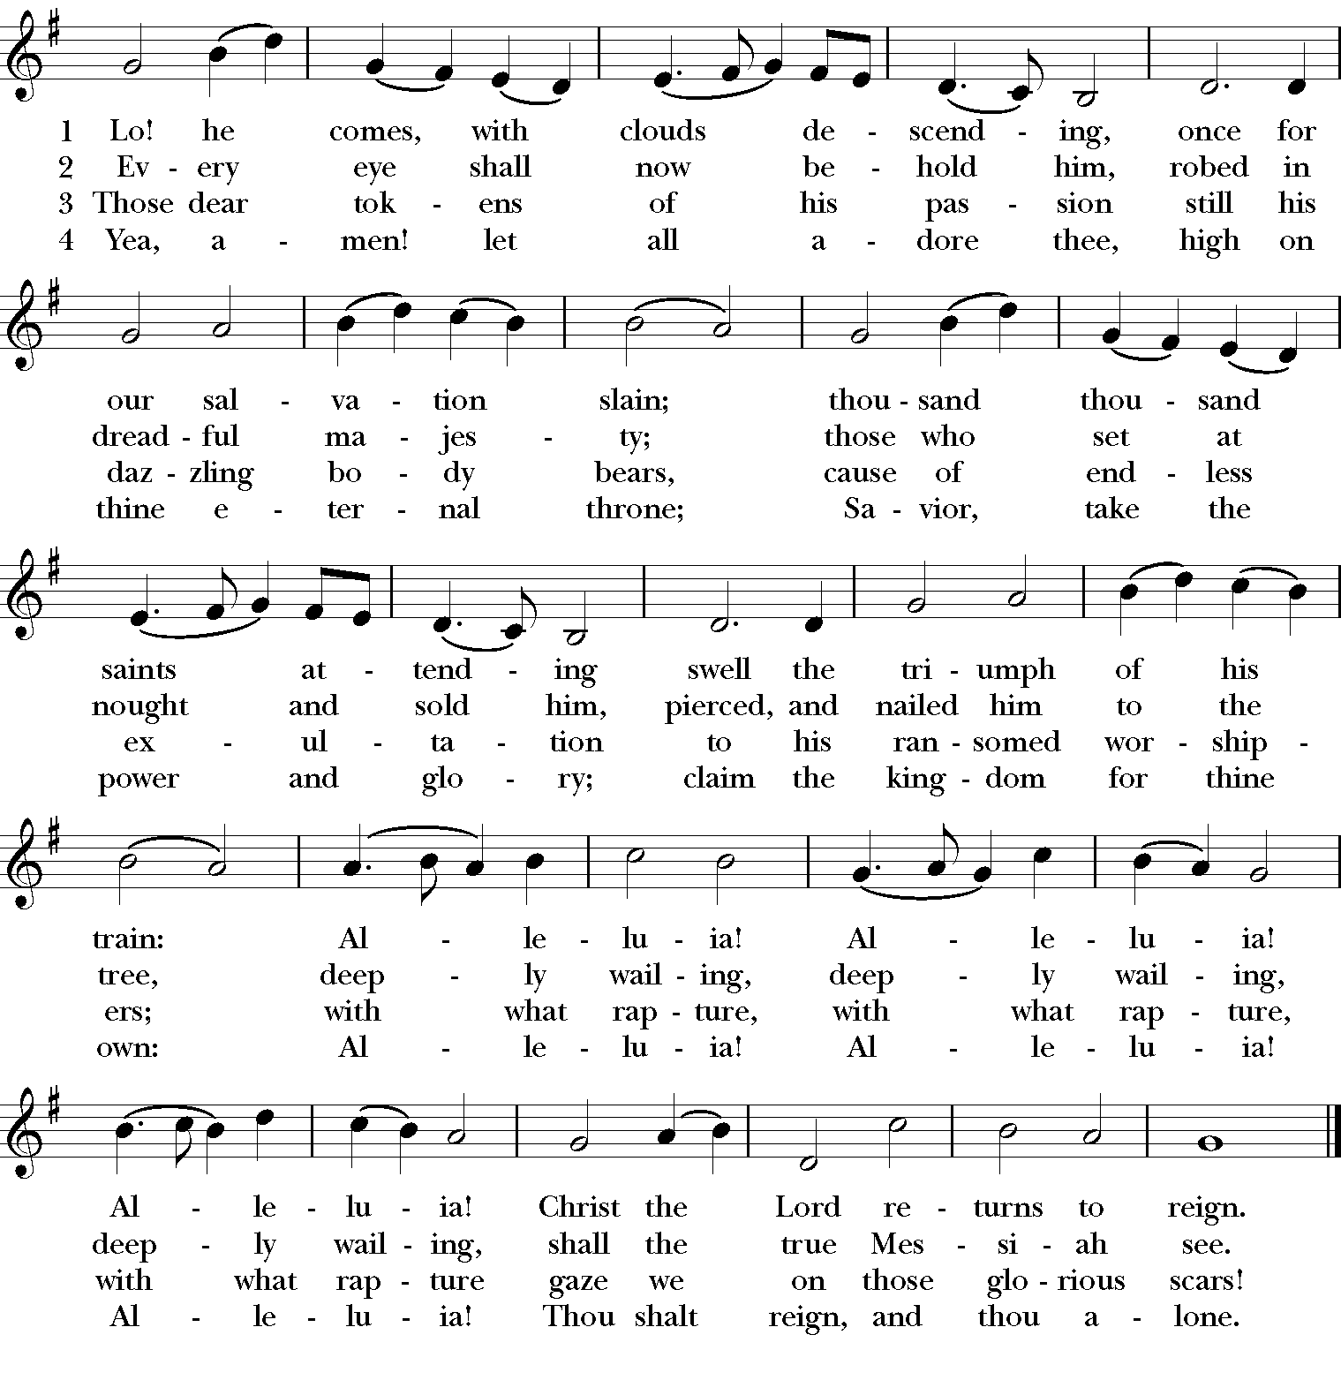

*All*

*Low voices*

*High voices*









*All* 4. Yea, amen! let all adore thee, high on thine eternal throne; Saviour, take the power and glory;

claim the kingdom for thine own: Alleluia! Alleluia! Alleluia! Thou shalt reign, and thou alone.

*Words: John Cennick, 1752; as altered by Charles Wesley, 1758; then altered by Martin Madan, 1760*

*Music:* Helmsley, *English melody; descant by Jeffrey Smith (b. 1960)*

**The Retiring Procession**

Voluntary: *Toccata on “Veni Emmanuel”* Andrew Carter (b.1939)

*Whether you are staying for Benediction or not, please join us for a reception in the Dining Hall, which begins immediately.*

**BENEDICTION OF THE MOST BLESSED SACRAMENT**

*All kneel as the bell is rung, signaling the exposition of the Most Blessed Sacrament.*

**Hymn** *O salutaris Hostia Wareham*

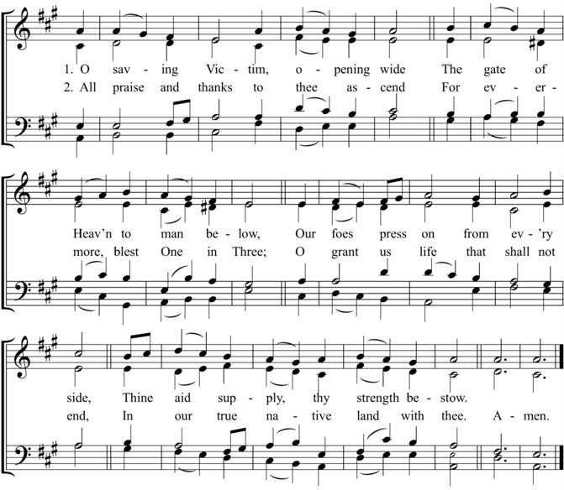

*Words: attrib. St. Thomas Aquinas (1225?–1274); tr. Edward Caswall (1814–1878)*

*Music:* Wareham*, William Knapp (1698–1768)*

**Meditation**

*The Officiant may pray aloud, or all may keep silence. At the conclusion of the Meditation, the officiant may say thrice, “Most Sacred Heart of Jesus,” to which the congregation responds,* **“Have mercy upon us.”**

**Hymn** *Tantum ergo Grafton*

*Words: attrib. St. Thomas Aquinas (1225?–1274); tr. after John Mason Neale (1818–1866)*

*Music:* Grafton*, from* Chants ordinaires de l’Office Divin*, 1881*

**Versicle, Response, and Collect**

*Officiant* Thou gavest them bread from heaven:

*People* Containing within itself all sweetness.

*Officiant* Let us pray.

O God, who in this wonderful Sacrament hast left unto us a Memorial of thy Passion: Grant us, we beseech thee, so to venerate the Sacred Mysteries of thy Body and Blood, that we may ever perceive within ourselves the fruit of thy Redemption; who livest and reignest, world without end. *Amen.*

**The Benediction**

*The people are blessed by the Sacrament.*

**The Divine Praises**

*Said by the Officiant, with all repeating each phrase.*

Blessed be God.

Blessed be his holy Name.

Blessed be Jesus Christ, true God and true Man.

Blessed be the Name of Jesus.

Blessed be his most sacred Heart.

Blessed be his most precious Blood.

Blessed be Jesus in the most holy Sacrament of the altar.

Blessed be the Holy Ghost, the Comforter.

Blessed be the great Mother of God, Mary most holy.

Blessed be the name of Mary, Virgin and Mother.

Blessed be Saint Joseph, her most chaste Spouse.

Blessed be God in his Angels and in his Saints.

May the heart of Jesus

in the most blessed Sacrament

be praised, adored and loved

with grateful affection

at every moment

in all the tabernacles of the world

even to the end of time. Amen.

*All stand as the bell is rung and the Most Blessed Sacrament is reposed.*

**Antiphon and Psalm 117** *Ego sum panis*

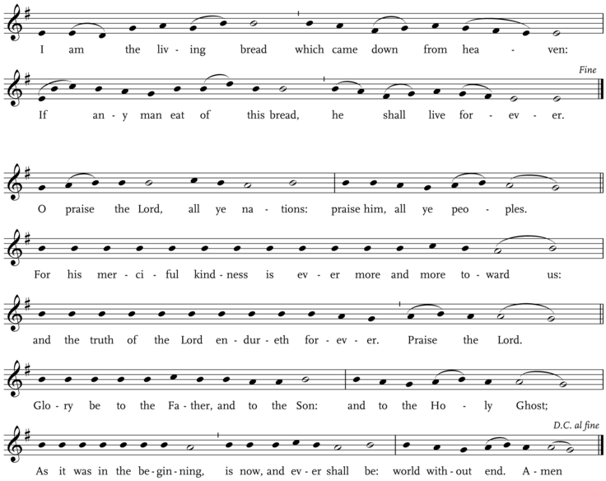

**THE READERS**

**First Lesson**

Eudora Neal

*Chorister*

**Second Lesson**

Mr. Scott Spaulding

*Senior Warden*

**Third Lesson**

Kris Brown Coleman

*Choir Member*

**Fourth Lesson**

Ms. Patricia Dresser

*Parishioner*

**Fifth Lesson**

Msgr. Paul Dudziak

*Pastor, Saint Stephen Martyr Catholic Church, Foggy Bottom*

**Sixth Lesson**

Ms. Denise Snyder

*Executive Director, Foggy Bottom West End Village*

**Seventh Lesson**

The Reverend Richard Wall

*Rector*

**Do you know a child who likes to sing?**

**Saint Paul’s Chorister Program**

**offers multi-faceted learning**

**in music, teamwork, leadership,**

**and development of character and intellect.**

**Exceptional Music**

• High standard of repertoire

• Emphasis on vocal training and music-reading skills using Kodály concepts

• History of touring, CD recordings; have appeared at the Kennedy Center

• Musical program modeled on the British college chapel and cathedral tradition

**Teamwork, Leadership, and Skills for Life**

• Each boy and girl receives significant individual attention in a challenging yet fun environment.

• The wide range of ages (7-14 for boys, 7-18 for girls) encourages teamwork: the younger children learn from older choristers.

• Field trips, choir parties, and tours foster bonding and strong friendships.

• No prior training or experience is expected or required.

• There are no expenses or tuition fees, unlike many comparable programs; the strong commitment parents and children make is all that is required.

• Children of any religious affiliation, or no affiliation, are warmly welcomed.

Our choristers make glorious music in the context of transcendent liturgy, while creating community both within the choir and as a part of the parish. Rigorous childhood music training has been shown to encourage well-balanced brain development that can improve academic performance and have other lasting benefits. Since few children, particularly boys, can envision the enjoyment and reward of a choir experience, parental initiative and involvement are critical when considering membership. St. Paul’s is easily reachable from the Foggy Bottom-GWU Metro stop.

Contact Interim Director of Music, Monica Berney at 202.337.2020 extension 14 or mberney@stpauls-kst.com

**Regular Service Schedule**

**Sundays** 9:00 a.m. Mass | 10:30 a.m. Solemn Mass

**Tuesdays &** 9:45 a.m. Morning Prayer | 10:00 a.m. Low Mass | 6:00 p.m. Zoom Evening Prayer (Tuesdays only)

**Thursdays**

**Wednesdays** 5:30 p.m. Prayers at the Shrine of Our Lady of Walsingham | 5:45 p.m. Evening Prayer | 6:00 p.m. Low Mass

**Saturdays** 11:30 a.m. Holy Rosary | 12:00 noon Angelus & Low Mass

**Upcoming Advent & Christmas Observances**

**Sunday, December 4**

4:00 p.m. Solemn Evensong & Benediction

**Sunday, December 11**

4:00 p.m. Solemn Evensong & Benediction

**Sunday, December 18**

4:00 p.m. Solemn Evensong & Benediction

**Monday, December 24** *Christmas Eve*

4:30 p.m. Sung Mass | 11:00 p.m. Procession, Blessing of the Crèche & Solemn Mass

**Tuesday, December 25** *The Feast of the Nativity of Our Lord: Christmas Day*

10:30 a.m. Solemn Mass & Benediction of the Most Blessed Sacrament

**SAINT PAUL’S PARISH**

*K Street — Washington, D.C.*

St. Paul’s Parish seeks to restore all people to God and to each other,

through sacramental worship and Christ-like living.

2430 K Street, NW

Washington, D.C. 20037

*phone*  202-337-2020

*web* www.saintpaulskstreet.org

*email* office@stpauls-kst.com

The Rev’d Richard Wall, *Rector*

The Rev’d Catherine Ann Ballinger, OSB, *Assistant Priest*

The Reverends Tony Lewis, Elizabeth Orens, J. Peter Pham, and Joe Thompson, *Assisting Priests*

The Rev’d Ethan Bishop Henchman, *Deacon*

Monica Berney, *Interim Director of Music*

Dylan Thayer, *Parish Coordinator*